|  |  |
| --- | --- |
|  | **HalaqaMetrash Web App** |

***CMPS356 Project Phase 1 – WebApp Design and Implementation***

|  |  |
| --- | --- |
| **Group Id:** | G5 |
| **G3 Group Members:** | Student1 Sadaf Hanif Baji (201304173)  Student2 Siti Nur Ummu Hani Binti Daud (201305129)  Student3 Dena Thsin Al-shekhly (201205502)  **Emails:** sb1304173@student.qu.edu.qa; sb1305129@student.qu.edu.qa; da1205502@student.qu.edu.qa; |

**Grading Rubric - In functionality column please specify either: Not done, Working, Done but not working**

|  |  |  |  |  |
| --- | --- | --- | --- | --- |
| **Criteria** | **%** | **Functionality\*** | **Quality of the implementation** | **Score** |
| **Application Design**  Architecture Design, Classes Design and the UI Design to deliver HalaqaMetrash use cases.  The design documentation should include at least the following:  • Application Architecture Diagram  • Class Diagram showing Entities, Repositories and Services and Controllers.  • UI Design and navigation.  • Discussion of design rationale of key design decisions. | 20 | * Working * Working * Working * Working * Working |  |  |
| **Complete and correct implementation of the requirements:** | 0 |  |  |  |
| * Login | 4 | Working |  |  |
| * Student Registration | 10 | Working |  |  |
| * List Tasks | 8 | Working |  |  |
| * Complete task | 8 | Working |  |  |
| * Delete task | 5 | Working |  |  |
| * Add Task | 9 | Working |  |  |
| * Update task | 5 | Working |  |  |
| * Messaging | 6 | Working |  |  |
| * Announcements | 5 | Working |  |  |
| * Student Follow-up (Parent/Coordinator) | 14 | Working |  |  |
| **Testing documentation** with evidence of correct execution using snapshots illustrating the results of testing. | 6 | Working |  |  |
| **Total** | 100 |  |  |  |
| Copying and/or plagiarism or not being able to explain or answer questions about the implementation | -100% |  |  |  |

**\* Possible grading for functionality**: ***Working*** (get 70% of the assigned grade), ***Not*** ***working*** (lose 40% of assigned grade and ***Not done*** (get 0). The remaining grade is assigned to the quality of the implementation. In case your implementation is not working then 40% of the grade will be lost and the remaining 60% will be determined based on of the code quality and how close your solution to the working implementation. Design quality includes **correct usage of MVC**, meaningful naming of identifiers, no redundant code, simple and efficient design, clean code without unnecessary files/code, use of comments where necessary, proper white space and indentation.

**Marks will be reduced** forcode duplication, poor/inefficient coding practices, poor naming of identifiers and unnecessary complex/poor user interface design.

# Design Documentation

# Application Architecture Diagram

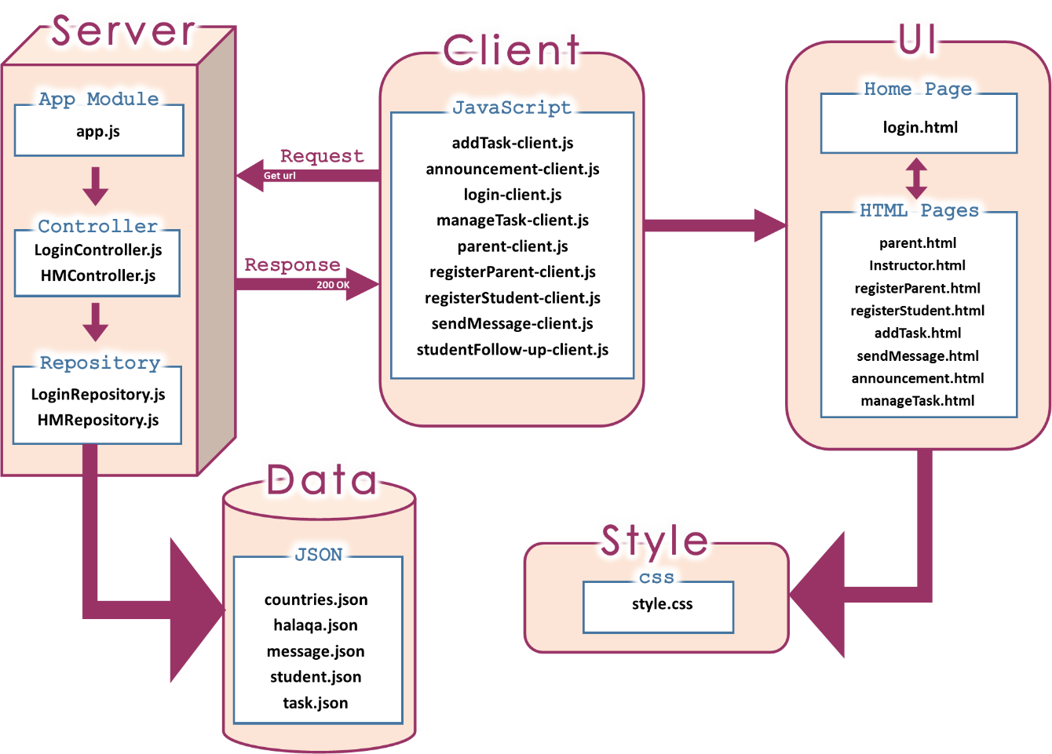

# Class Diagrams: Entities, Repositories and Services and Controllers

## Entity Class Diagram

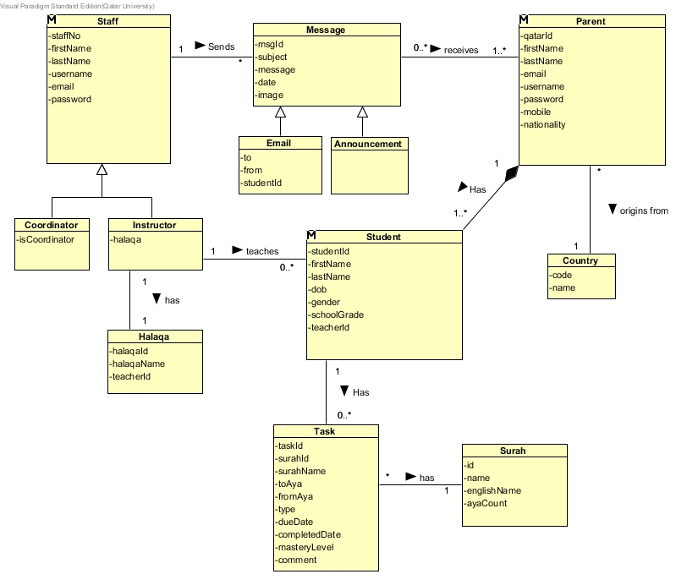

**Repository Class diagram**

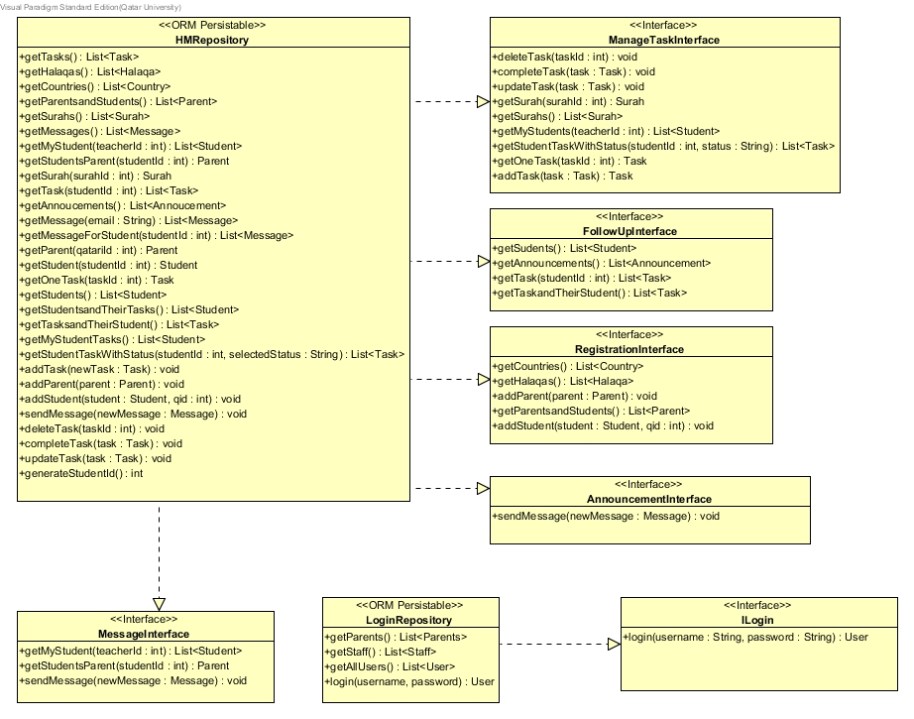

**REST Service Class diagram**

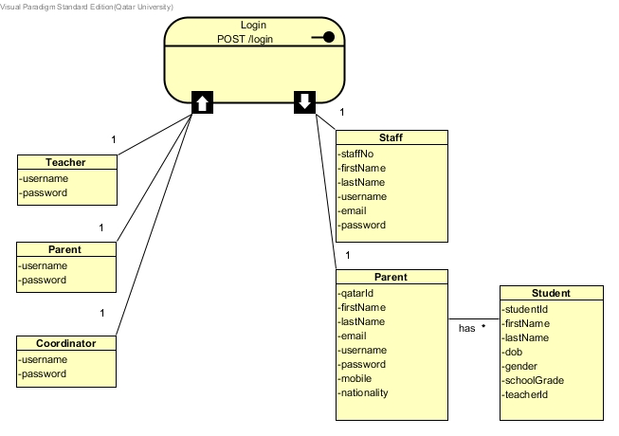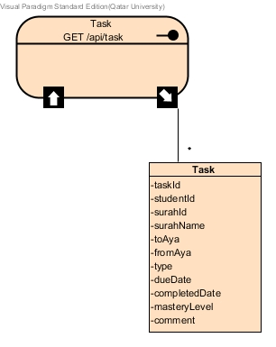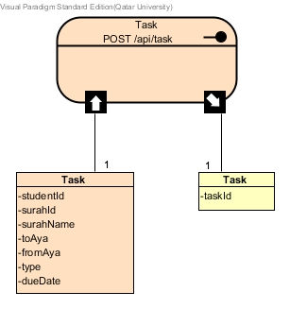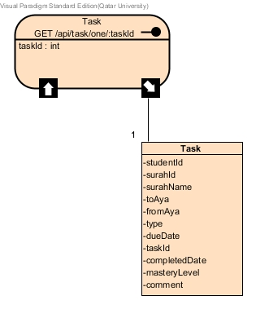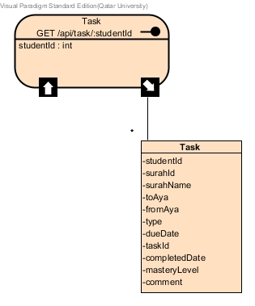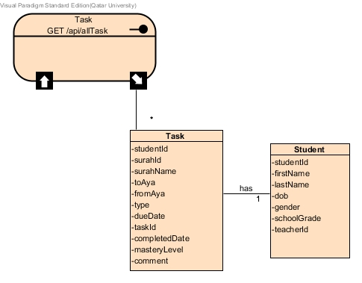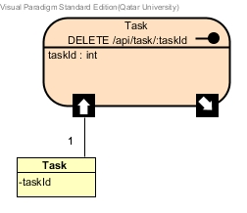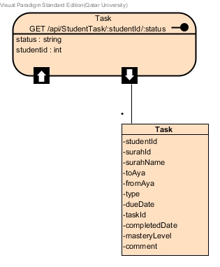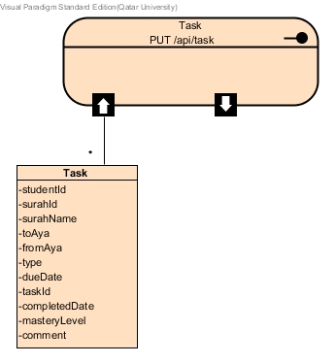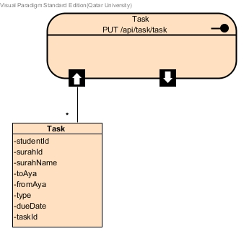



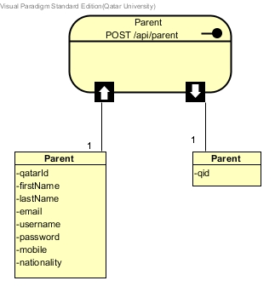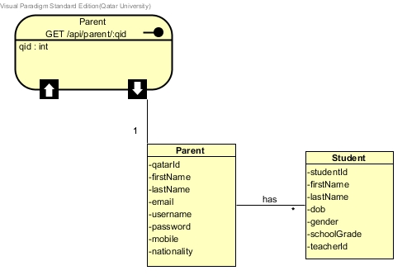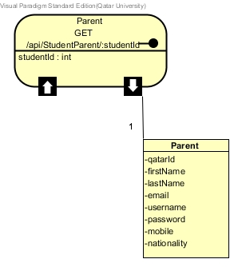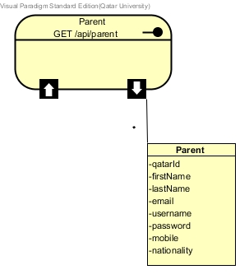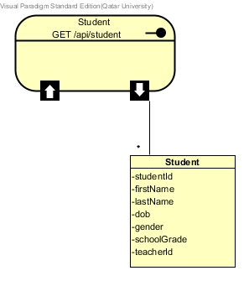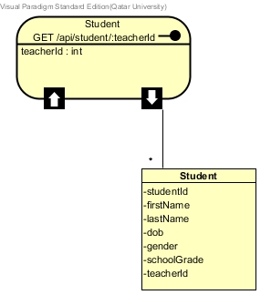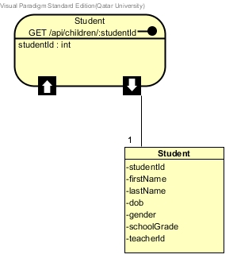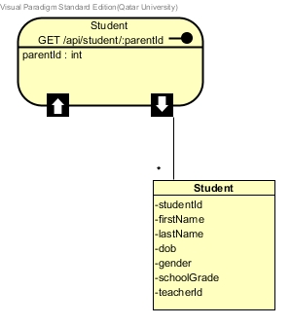

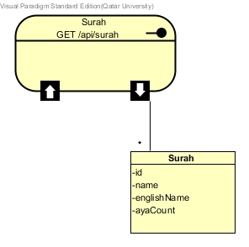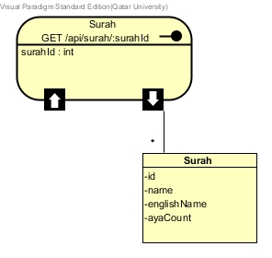

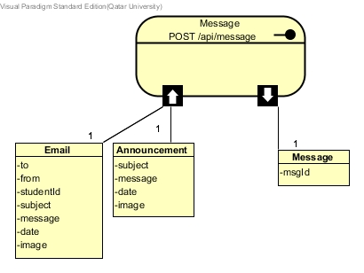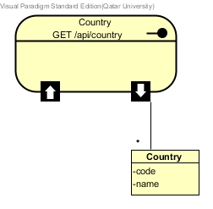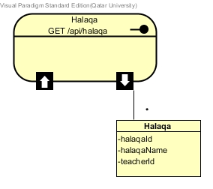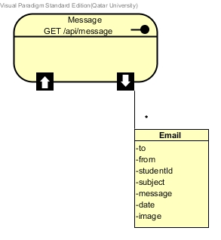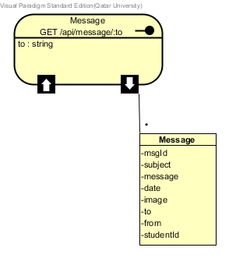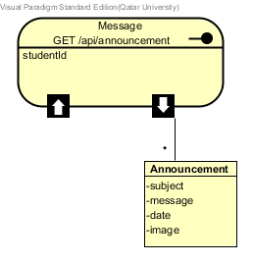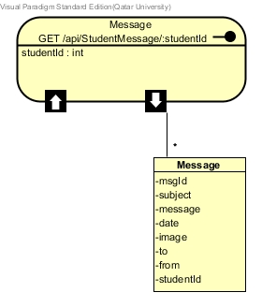

**Controller Class Diagram**

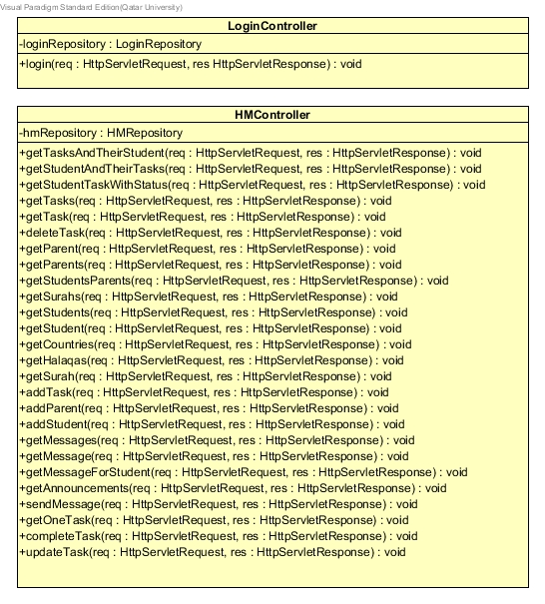

We decided to use one repository dealing with login/authenticate the user and another one for all the application to cover the specified use cases. The reason we module it this way is because the system is relatively small therefore we don’t see the need to have smaller controller/repositories for this application. Having all this together also eliminate duplication. Yes, there is some function that is unrelated but they are too small to put in a separate module.

# UI Design and navigation

Same login interface login.html is accessed by teachers, coordinator & parents. Instructors’ homepage is instructor.html, they have access to sendMessage.html and addTask.html. The home page for coordinator is studentFollow-Up.html. This page is also shared with parents, however the view for coordinator is different to the view for parents as shown below. Coordinator has access to registerParent.html, registerStudent.html and announcement.html. Lastly parents’ homepage is parent.html, they have access to studentFollow-up.html where the view is customised for parents, making it different to the one for coordinator.

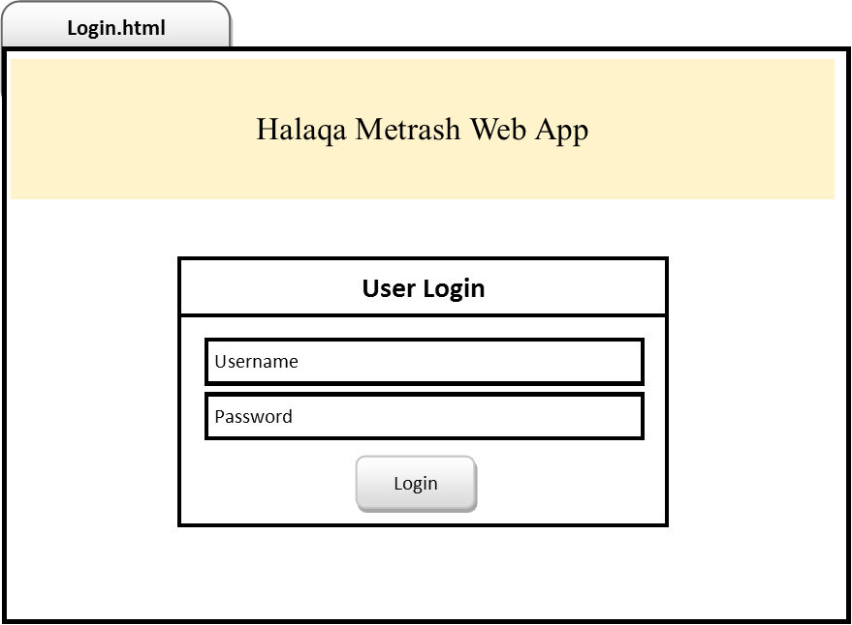 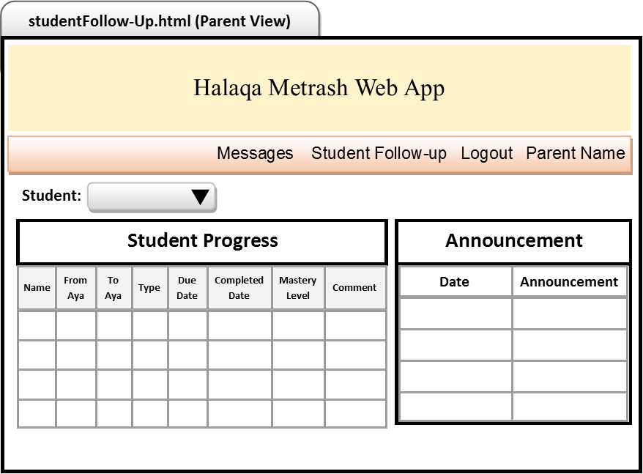

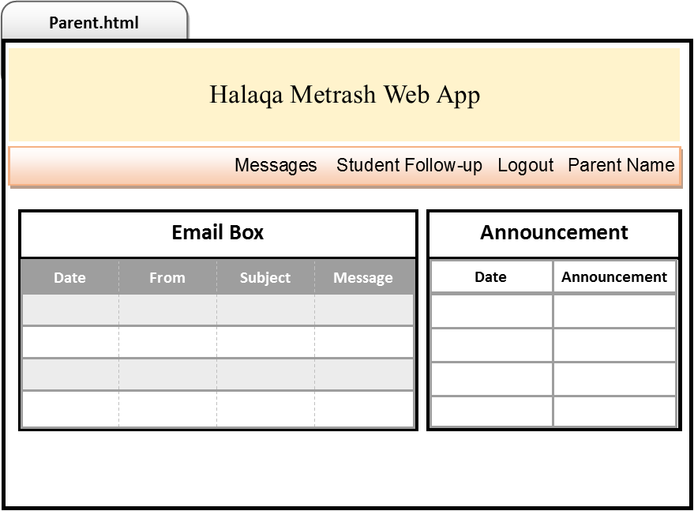 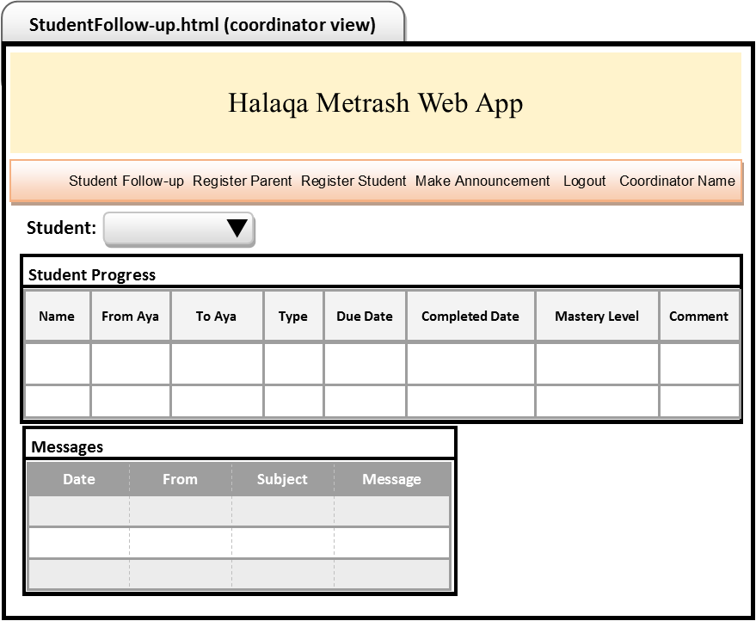

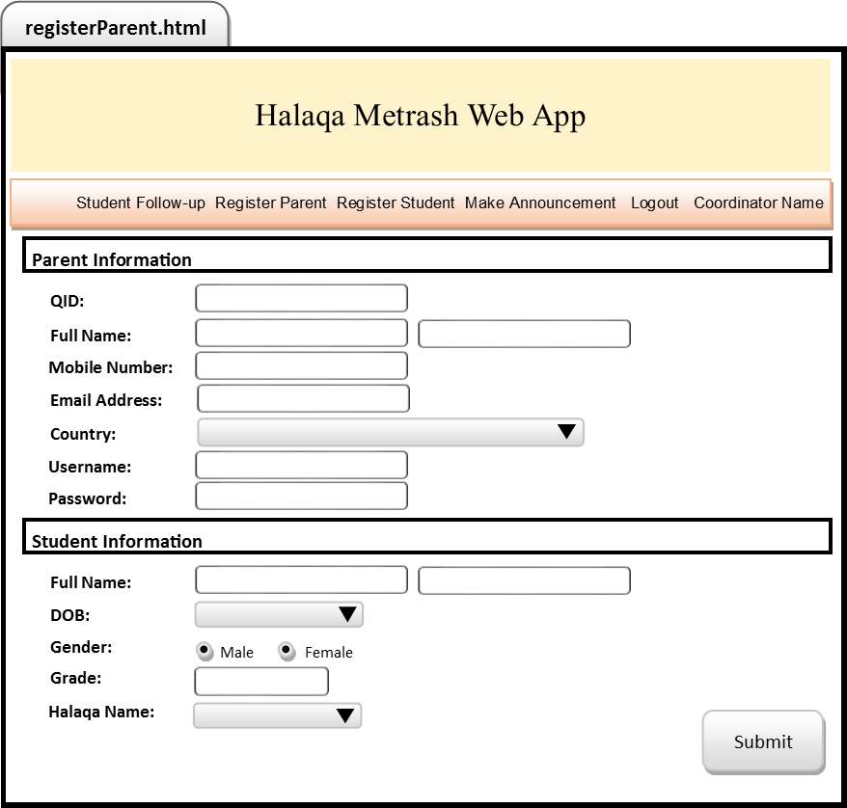 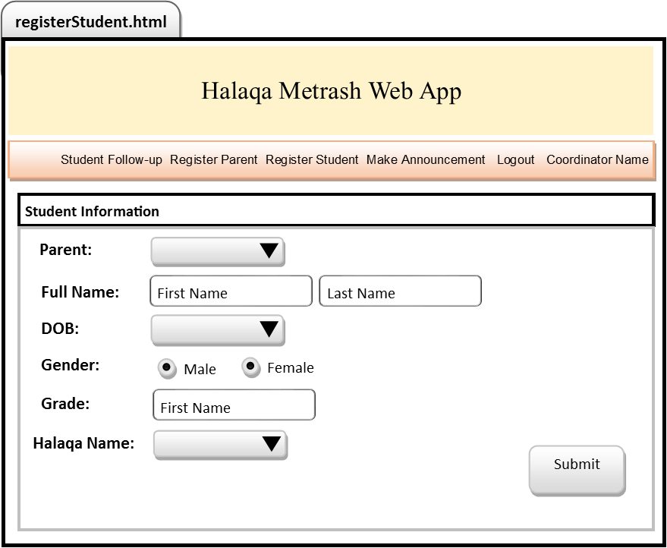

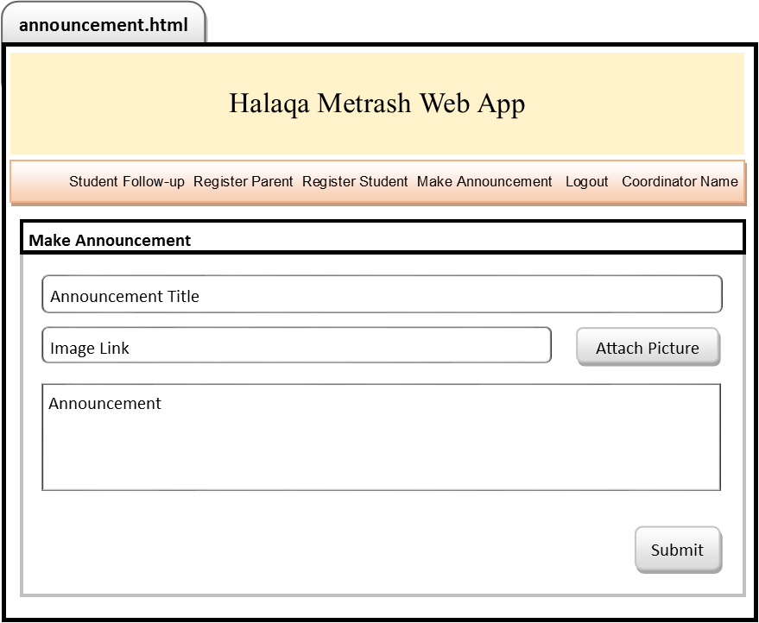 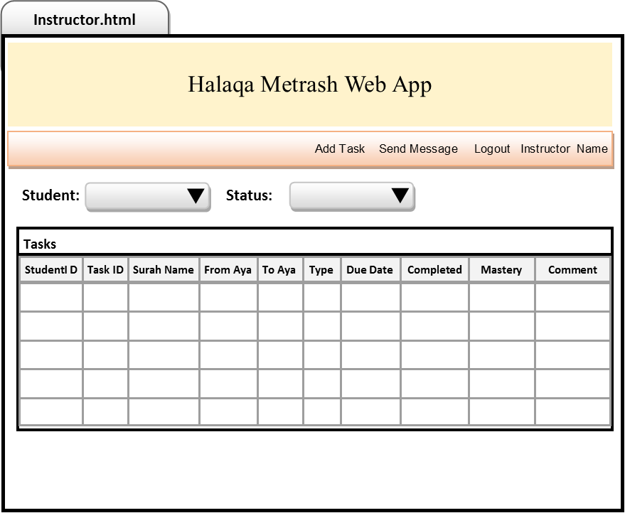

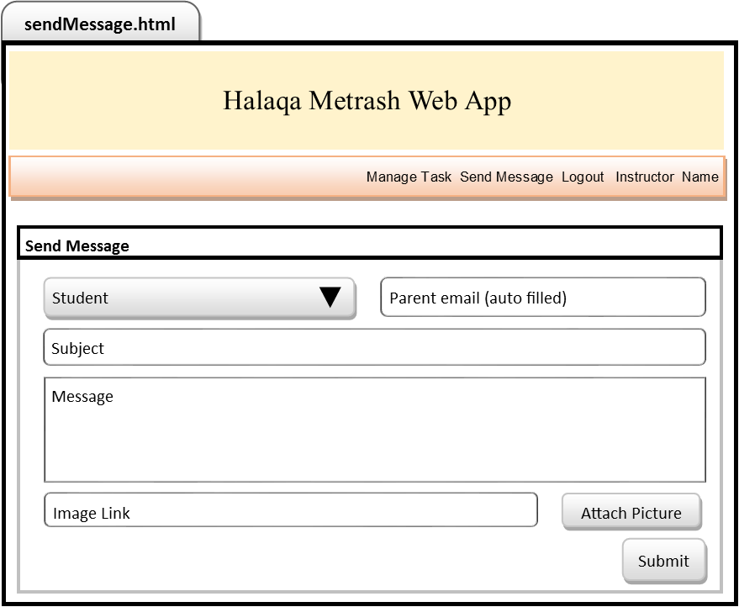 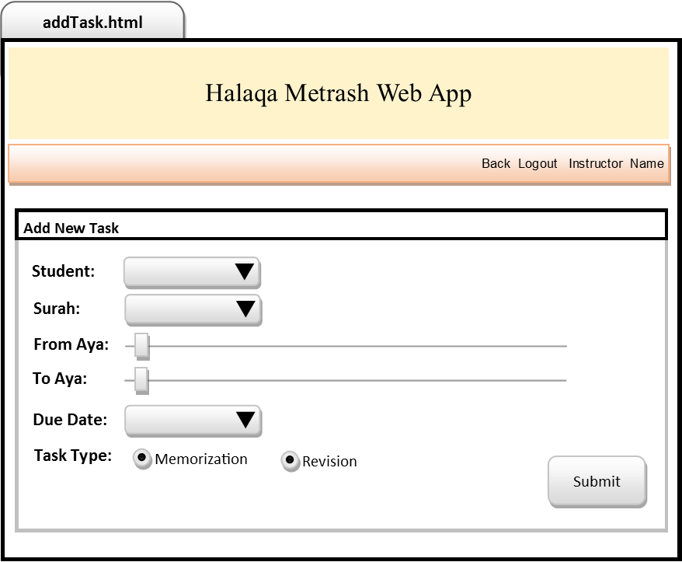

# Discussion of design rationale of key design decisions

1. We used MVC design pattern to organise our code into appropriate categories without mixing them up. This makes it easier to understand the architecture of the system, also makes it more adaptable to changes which is very important when it comes to web applications as changes are constantly made to enhance the service. Using MVC means that parts of the code can be modified without causing a havoc in the existing codes. We placed all the model (data) in a folder called ‘data’. Then we placed all the views in a different directory. And lastly separated the controllers.
2. We used 2 repositories, LoginRepository and HMRepository. The reason we chose to do this is because the login required completely different functionalities, validation and authentication compared to the rest of the system. We decided to keep it separate from the rest of the system functionalities. The idea behind keeping the rest of the functionalities in one repository was to avoid duplication of functions, as different parts of the application sometimes required the same functionality but for different purpose. So to avoid code repetition we grouped it all into one repository. This meant that we also had 2 controllers as it made sense to have one controller for each repository.
3. We decided to limit the number of html pages to one per each major use case to improve user experience, which means reduce the number of clicks and need to go back and forth in pages. We split the register student use case into two html pages because there were two parts to this use case; register parent and register student. It seemed more logical to separate the two, so we had register parent along with 1 child in one html page, and another html page to register another child later one. For the manage tasks use case we created 2 html pages. The reason for this was because we wanted the manage tasks html page to display the tasks for each student according to the status, and update task, complete task, and delete task were appending/deleting pending tasks, so for this it was logical to have a button along with popup box which allows this, so the user doesn’t have to change pages in order to perform this task. However, add task was creating a new task so we created a separate html page for that. This gave us a total of 9 html pages for 10 use cases.
4. We separated the css from the HTML to make it more flexible to design change. By doing this it makes it easier and more convenient to modify the visual appearances of our html pages, in other words the look of the user interfaces. In the future if the color scheme or fonts/styles need to be changed without changing the layout of the webpage, it can easily be done by simply modifying the stylesheet used and not touching the html pages.
5. Apart from our own stylesheet we also use ready-made stylesheet such as jquery-ui to reduce our development time on the design. We also thought that since it is open source and available it is wise to utilize it instead of building everything from scratch. We do not use this heavily, in fact only one page which is the manageTask.html that uses it to make the dialog form appeared readable and elegant. Another library we use in our project is moment.js. The reason for this is because the date stored in our task.json was in the format **dd-mm-yyyy** and by default javascript stored date as **MM-dd-yyyy** therefore we use moment.js library in order to make our date stored in a consistent manner.
6. We used responsive page designs for the html pages to enrich the user experience. This was done so that no matter how big or small the screen of the device the user is using, the user interface of our system will always remain user friendly, adjusting the layout of the webpages to continue looking professional and at the same time make navigation for the user easier. The menu was made to appear in row form on a big screen, and to collapsed menu when the user is using a small screen device. The content of the page was made to move so that the user doesn’t have to scroll across the page to view the whole page when using a small screen.

# REST Service Testing

# Login

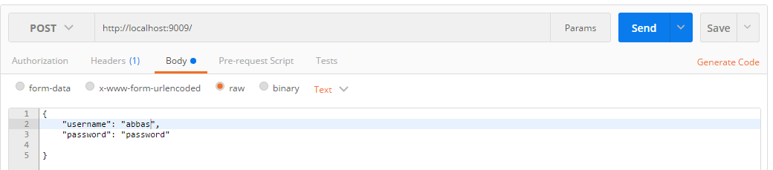

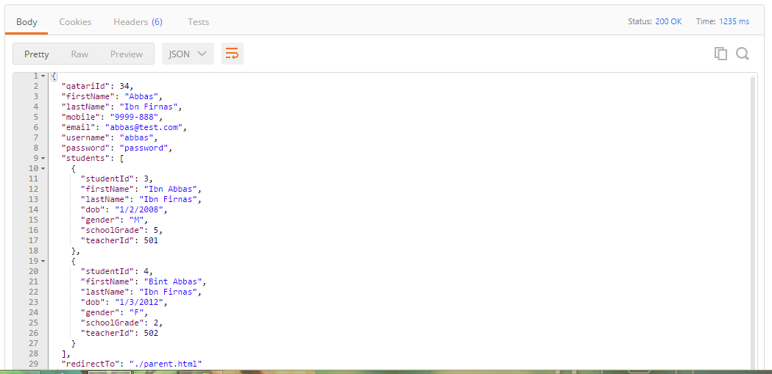

# Student Registration

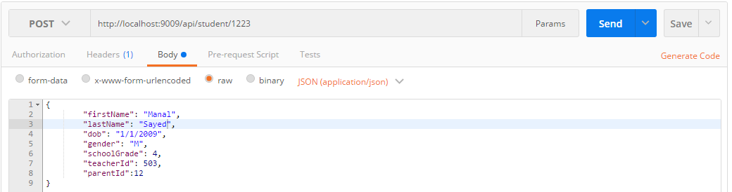

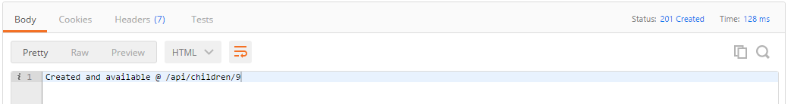

Check:

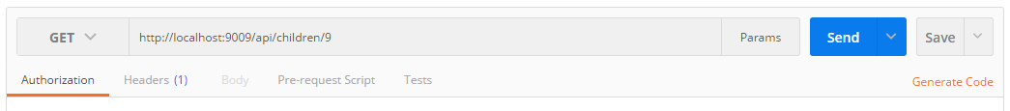

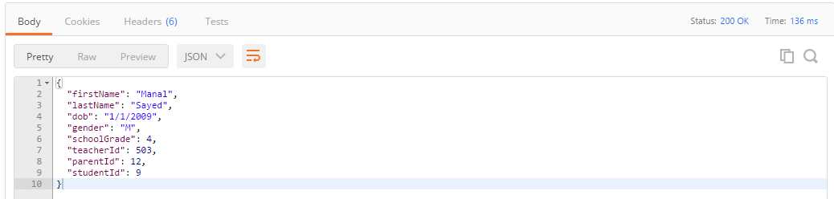

# List Tasks

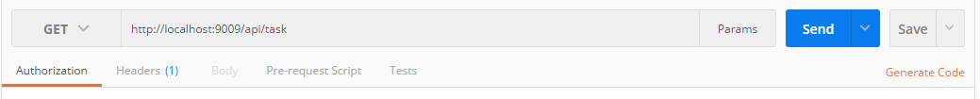

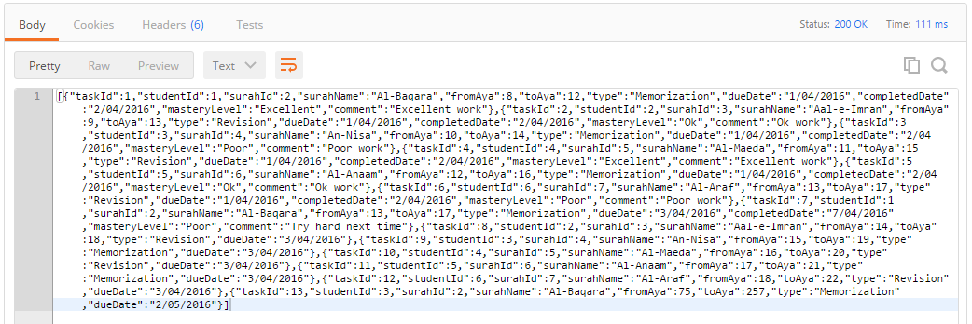

By studentId:

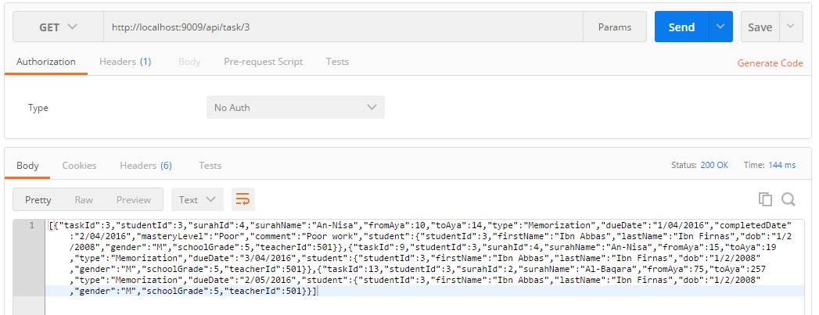

By taskId:

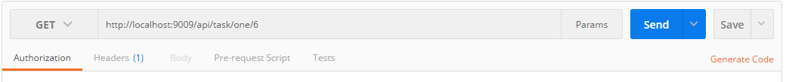

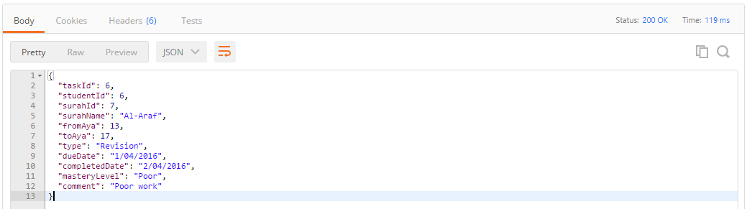

# Complete task

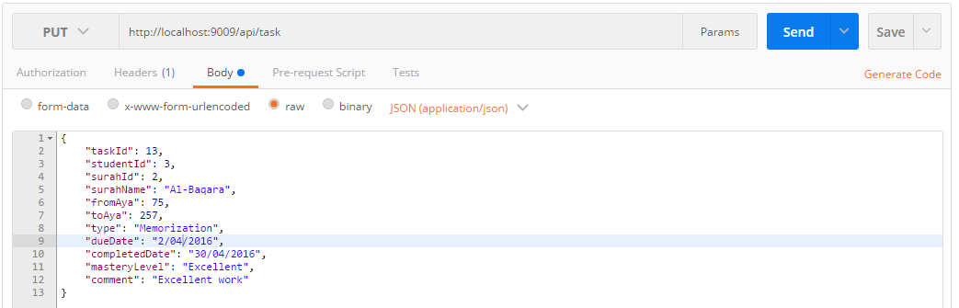

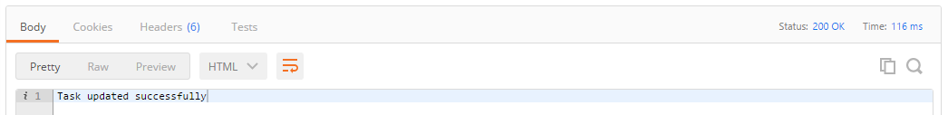

Check:



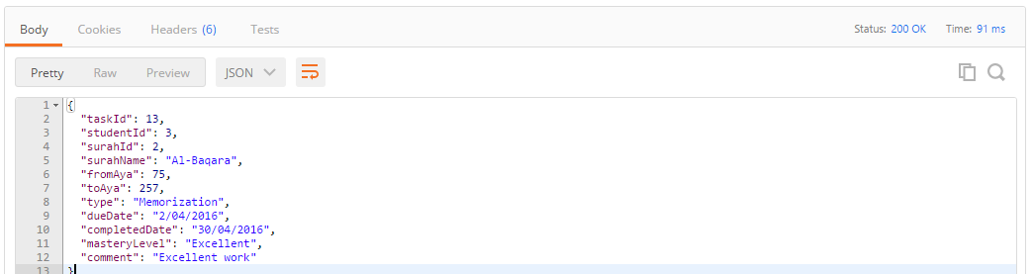

# Delete task

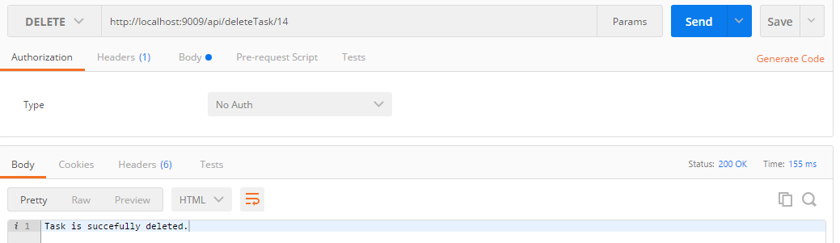

Check:

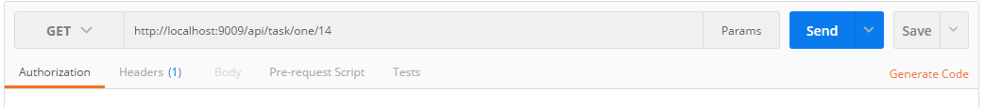

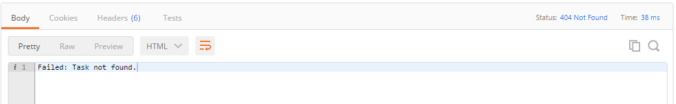

# Add Task

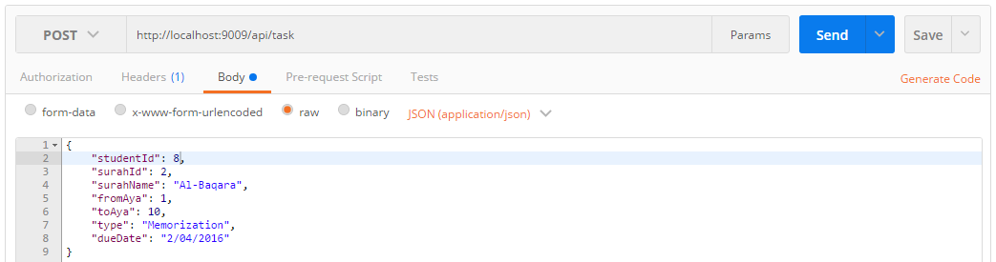

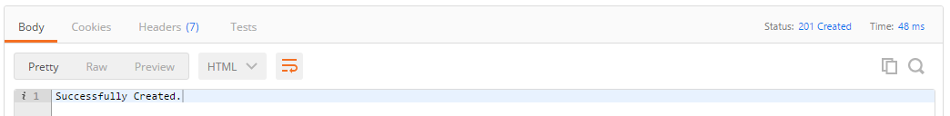

Check:



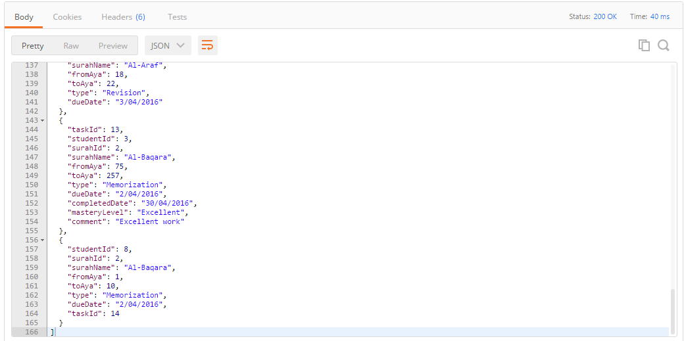

# Update task

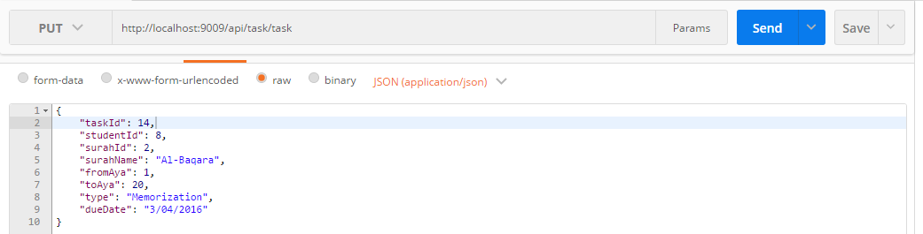

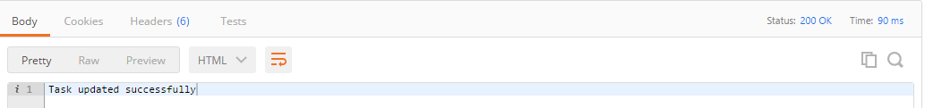

Check:



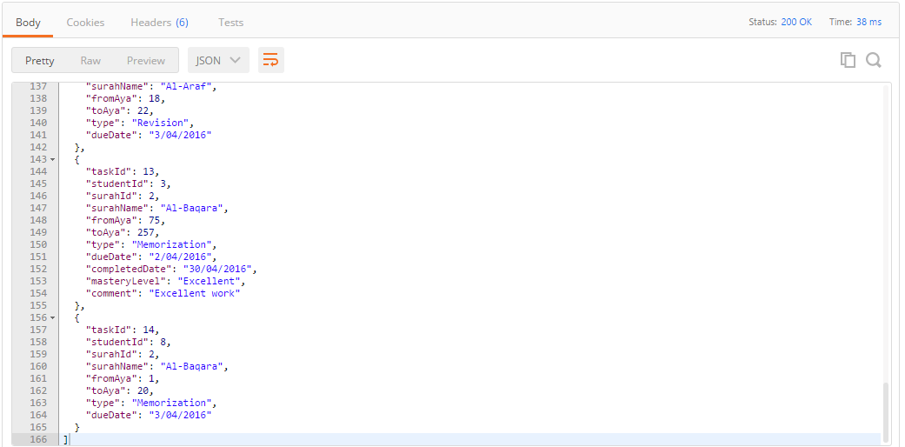

# Messaging

Send message:

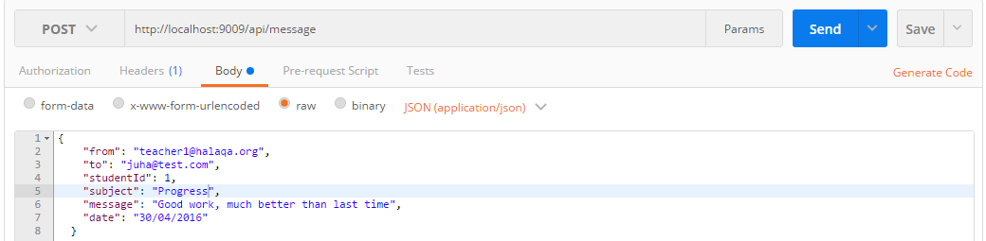

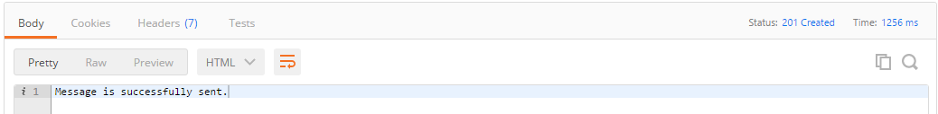

List message:

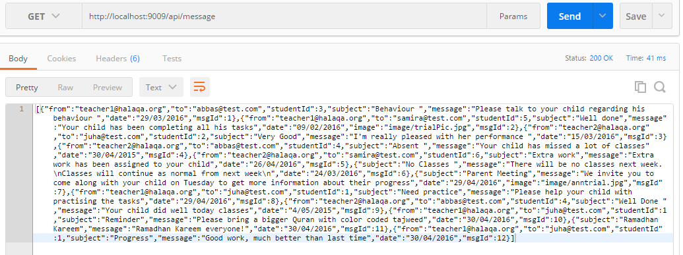

List message by studentId:



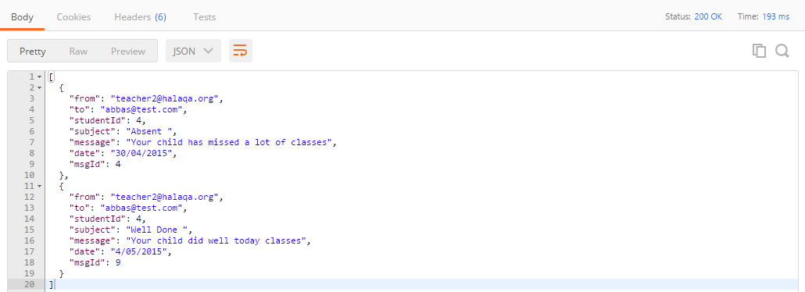

List message by parent’s email:



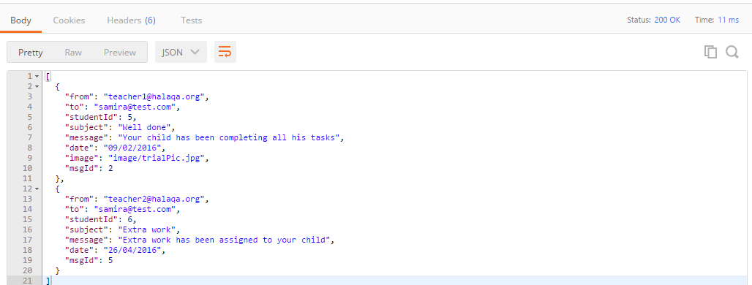

# Announcements

List Announcement:

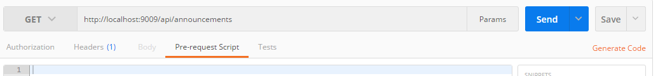

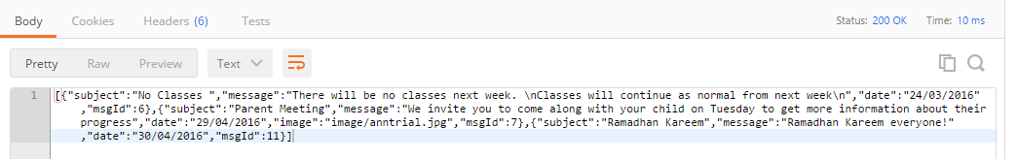

Send announcement:

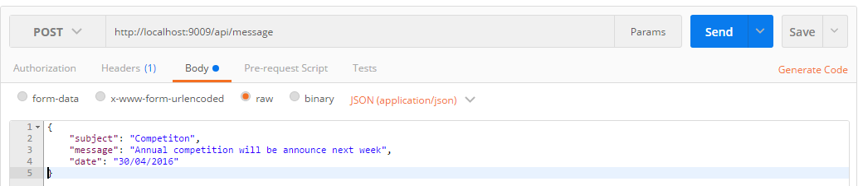

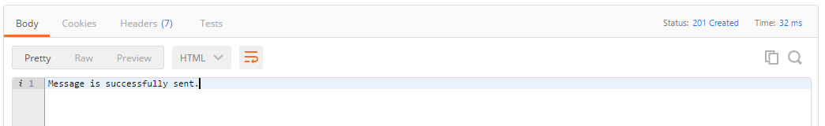

Check:



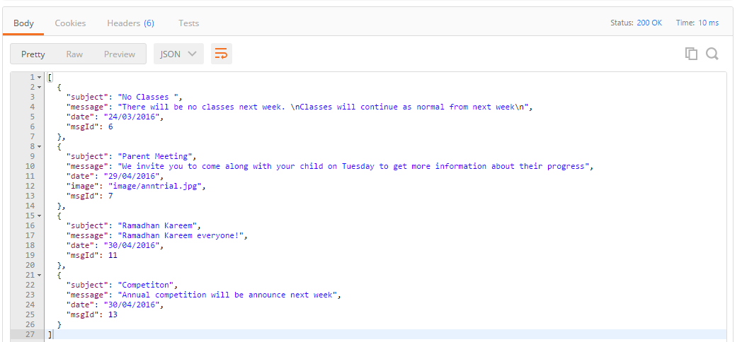

# Student Follow-up

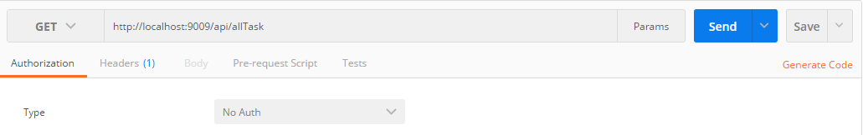

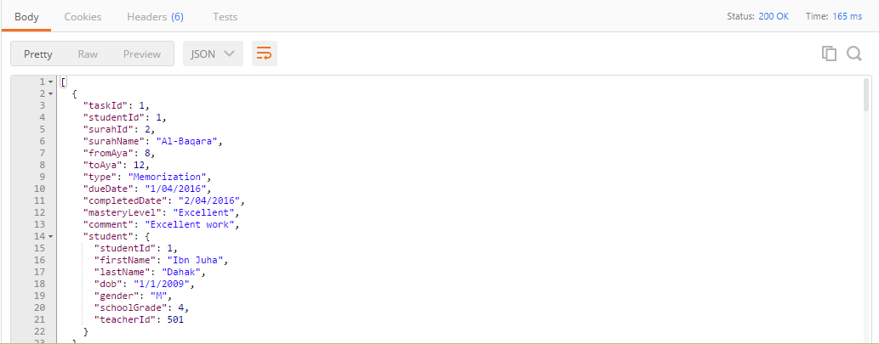

# User Interface Testing

# Login

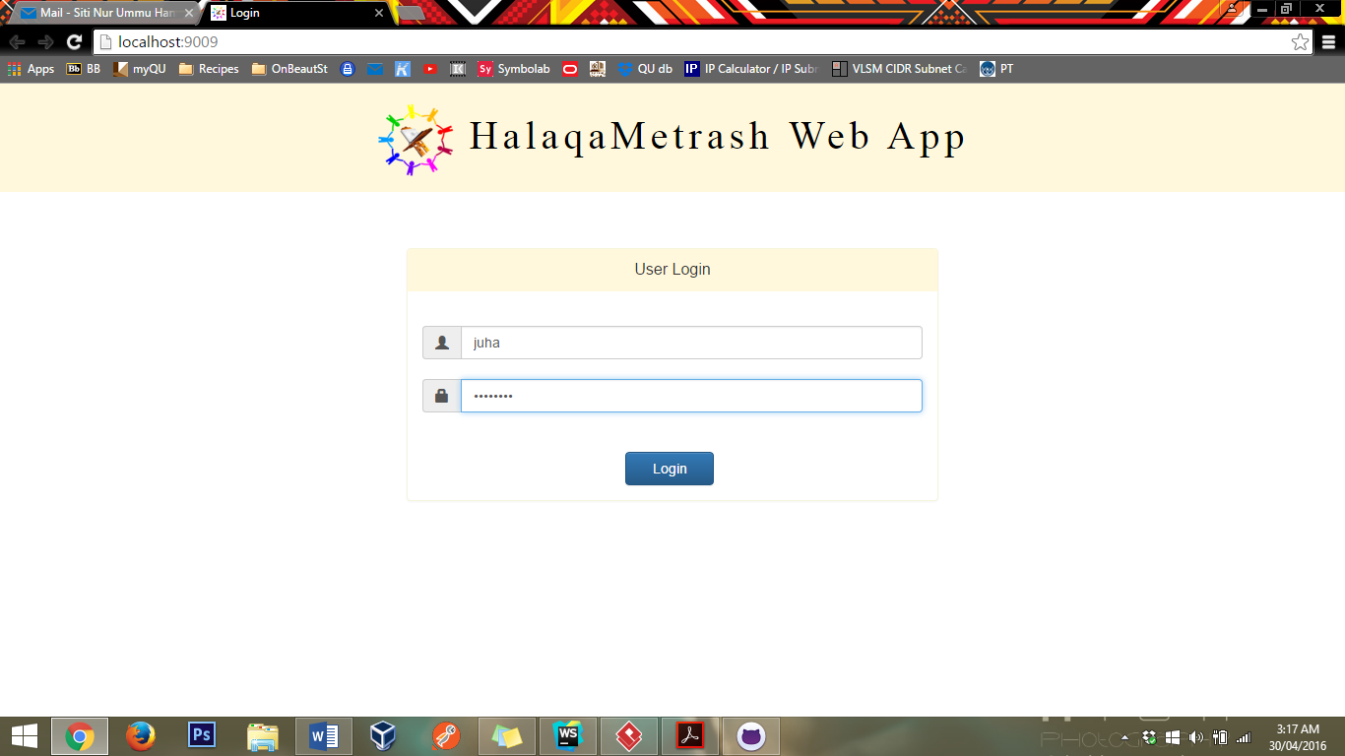

Parents Logging in

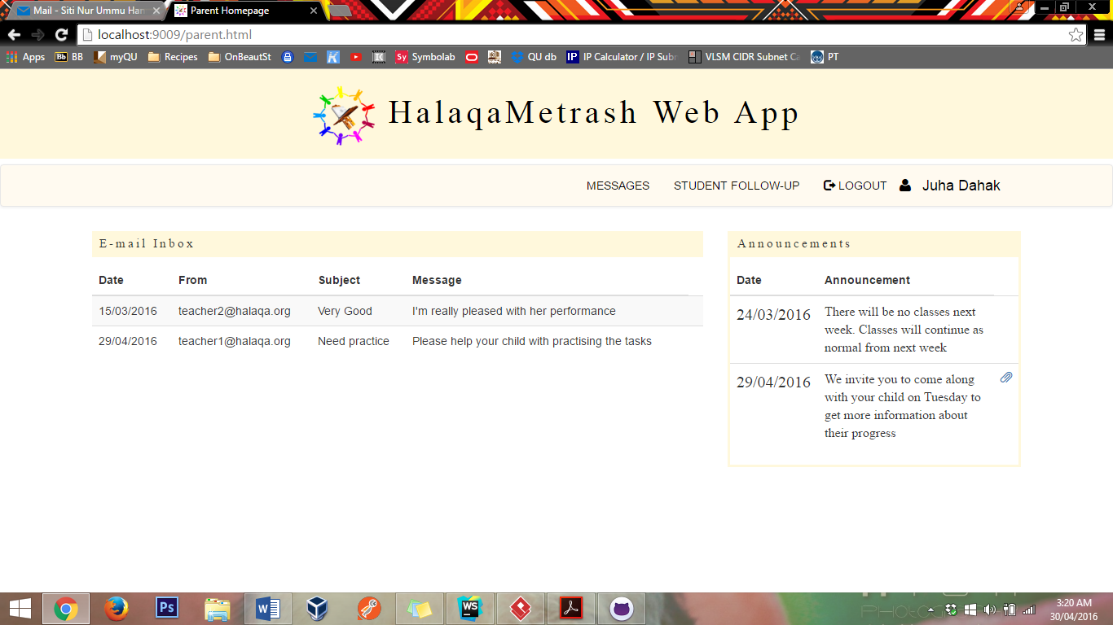

Parent’s name

Announcement bar on the right hand side

Mail from teacher shown here

Parent homepage

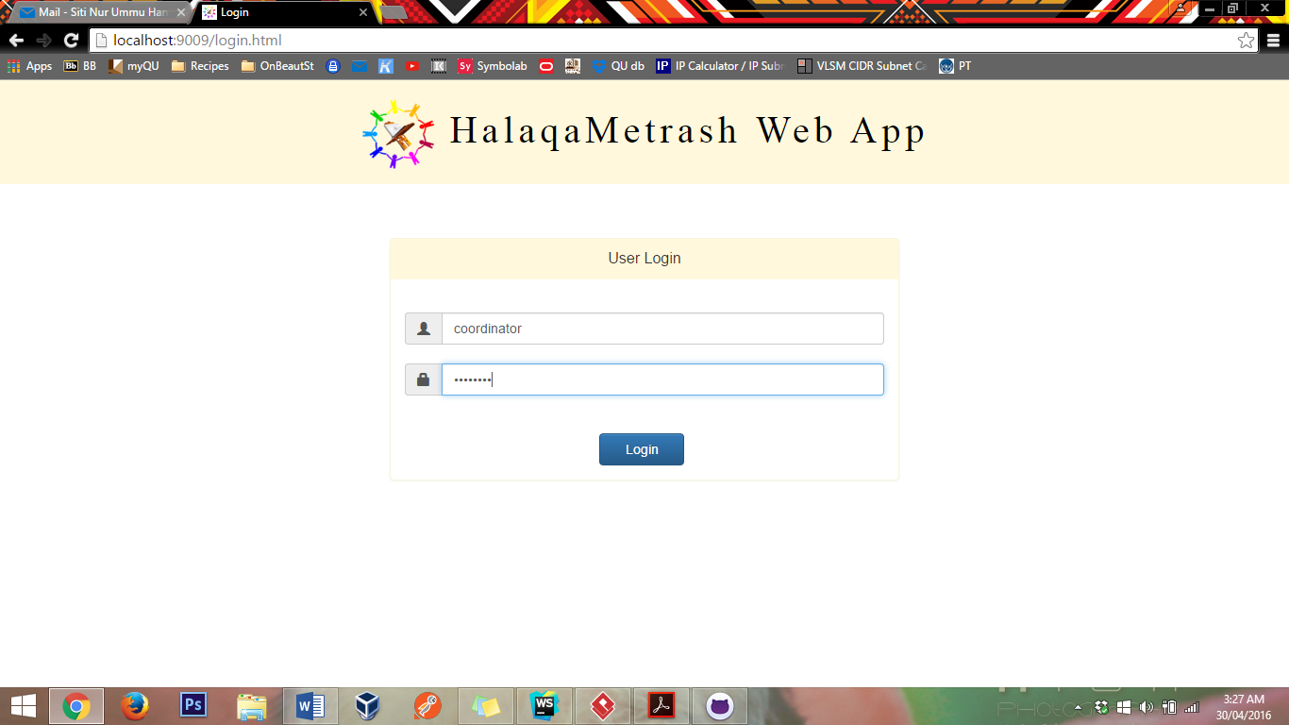

Coordinator’s name

Coordinator logging in

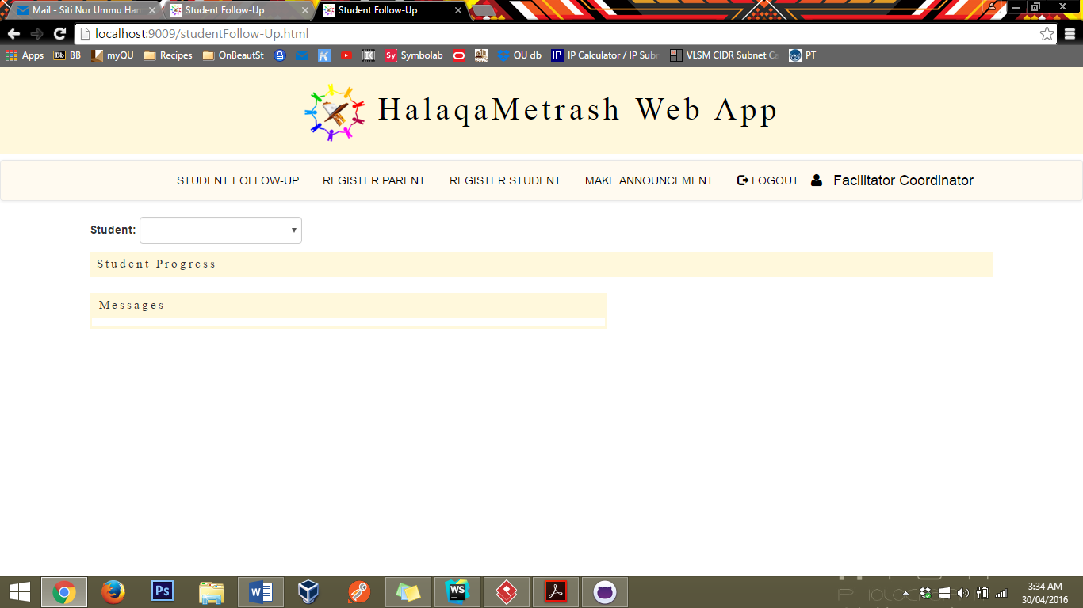

Follow up page will display after successful login

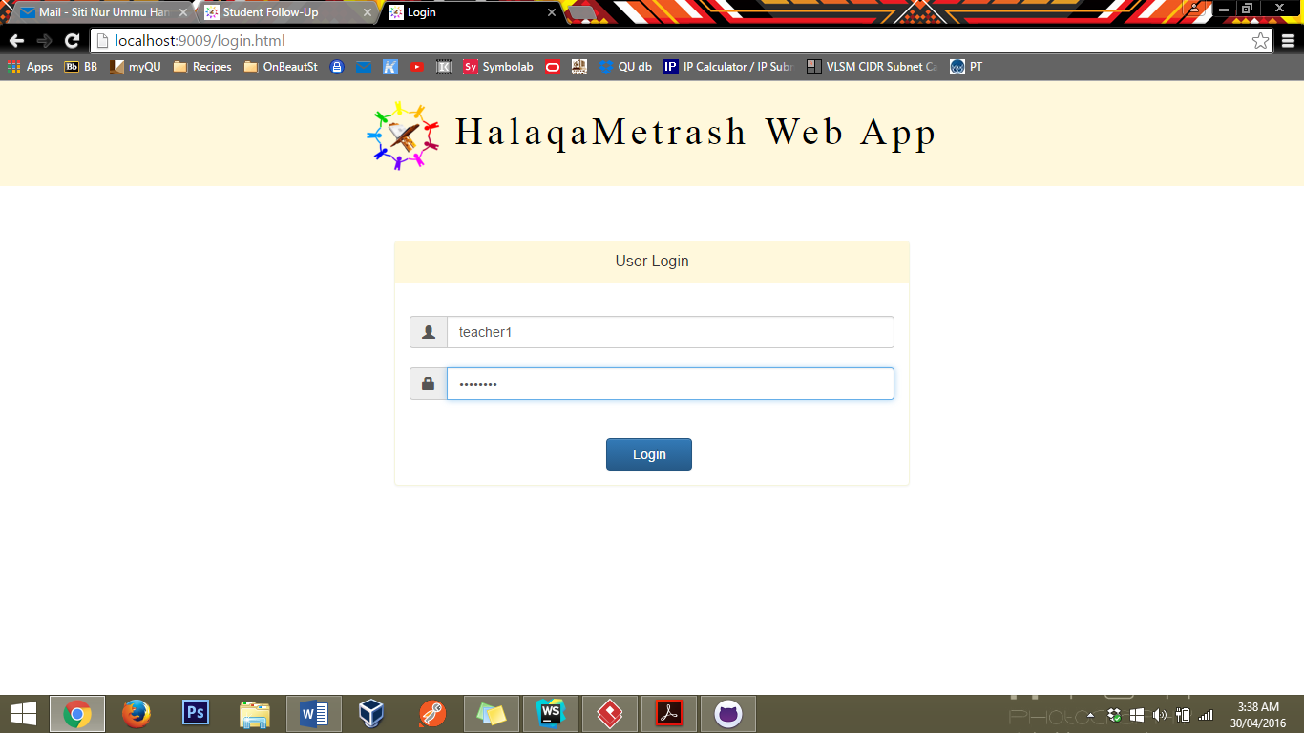

Teacher logging in

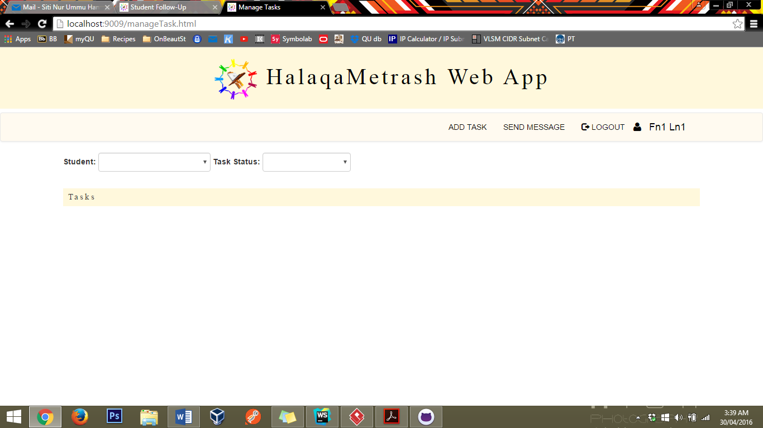

Teacher’s name

Manage task will be display after teacher logs in

# Student Registration

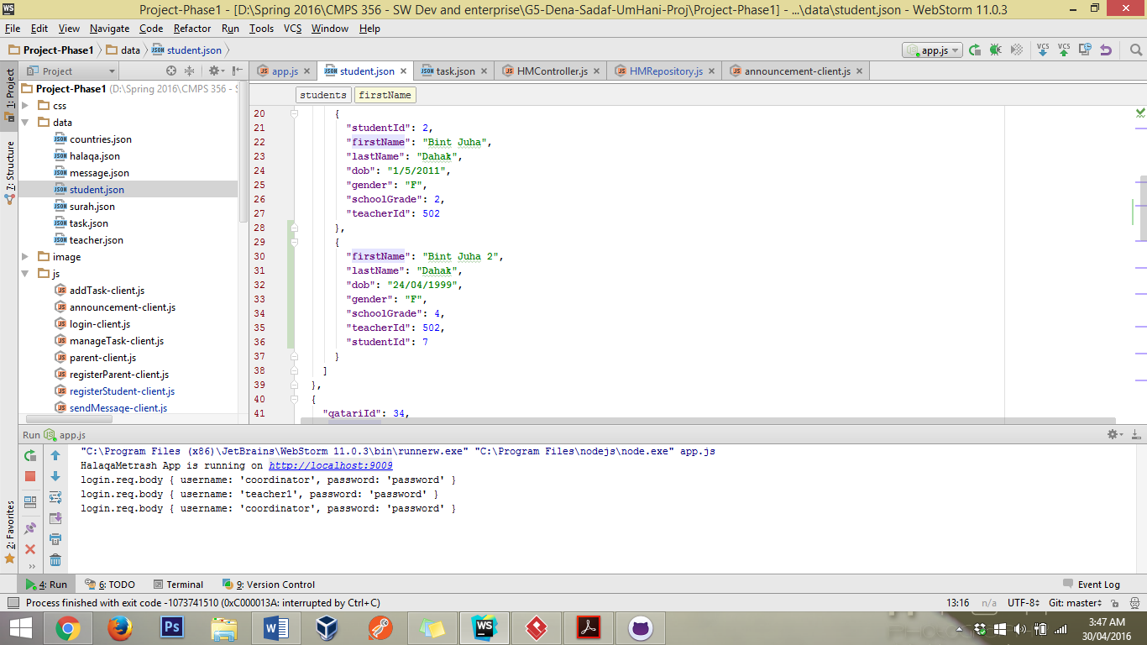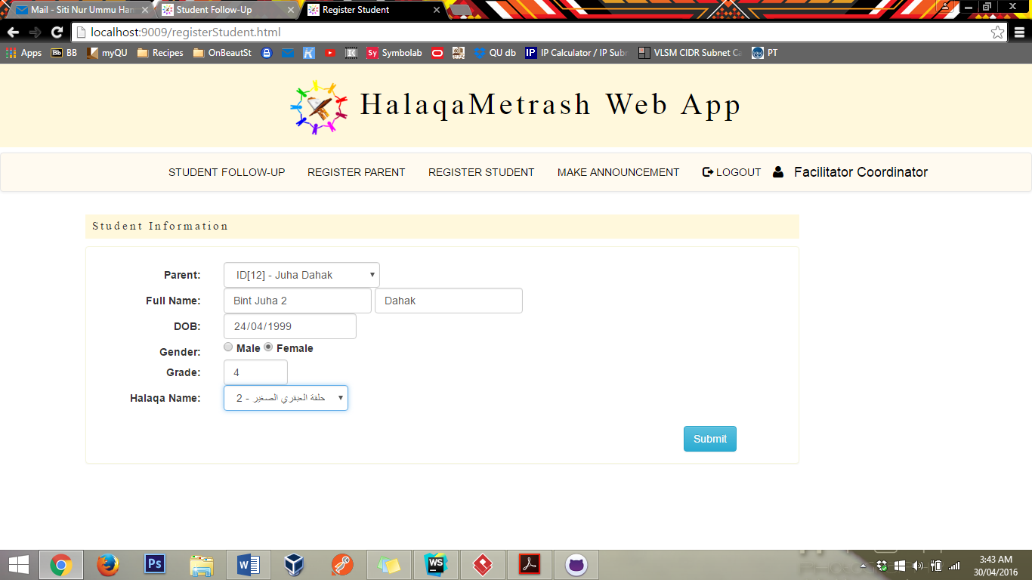

1. Choose existing parent

2. Fill all the fields

3. Submit

Once submitted the JSON file is updated with the new record

Submitting an empty form or missing fields will result in this error

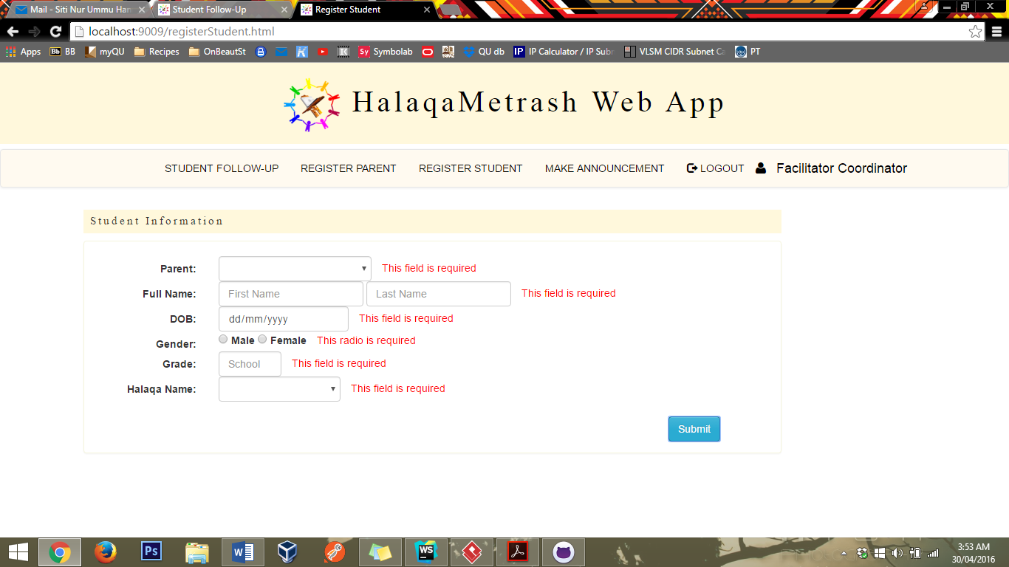

Another way to register student is when parent record does not exist in the system therefore, go to Register Parent page.

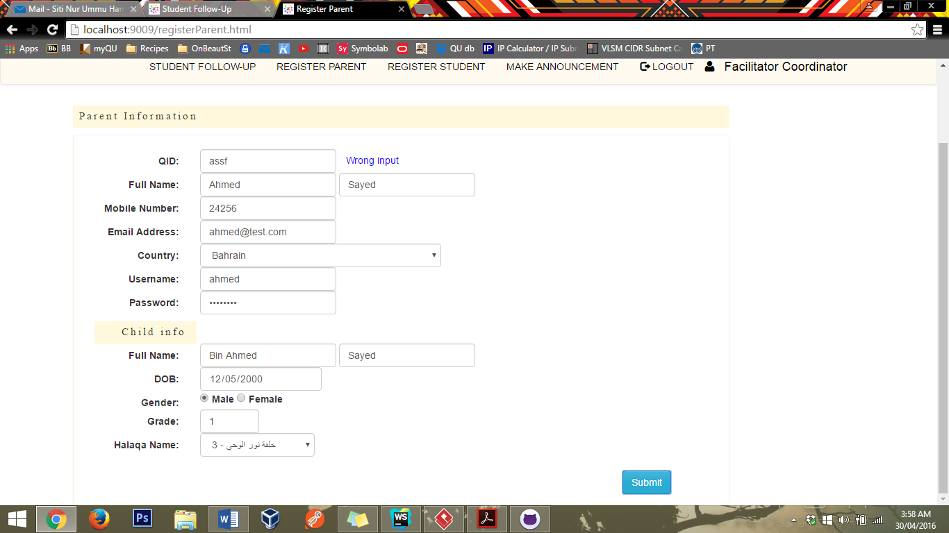

Entering non digit in QID field will result in this error.

This form also rejects any missing fields (for the parent part). However, the child part is optional.

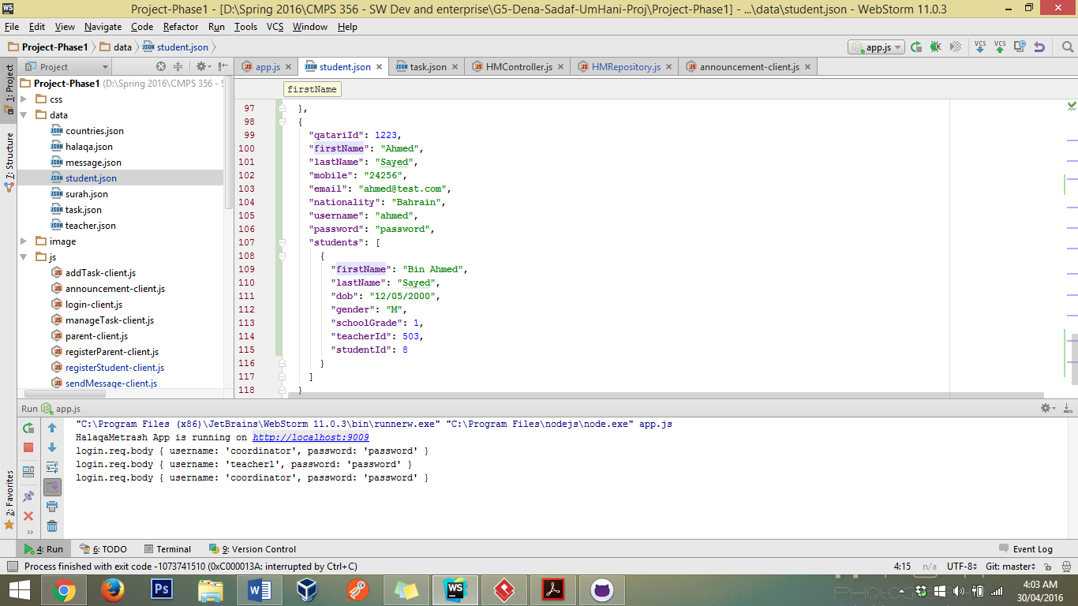

Result in JSON after successful registeration.

# List Tasks

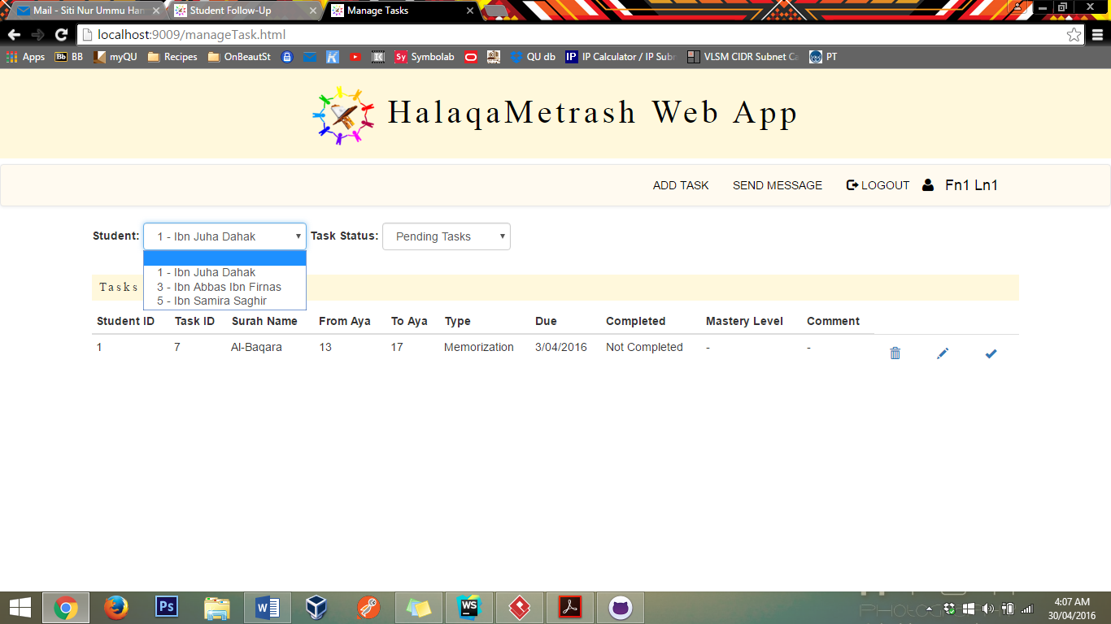

Teacher1 can only view his students task.

First select student then status

teacher1 page

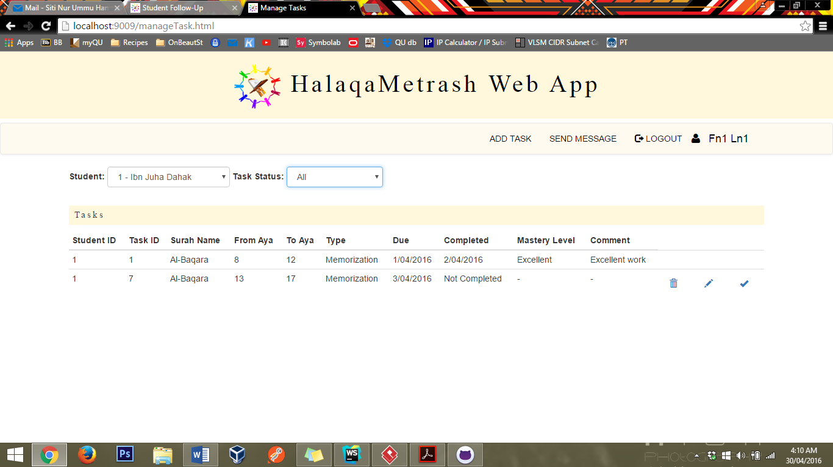

# Complete task



Choose a task then click on the check mark

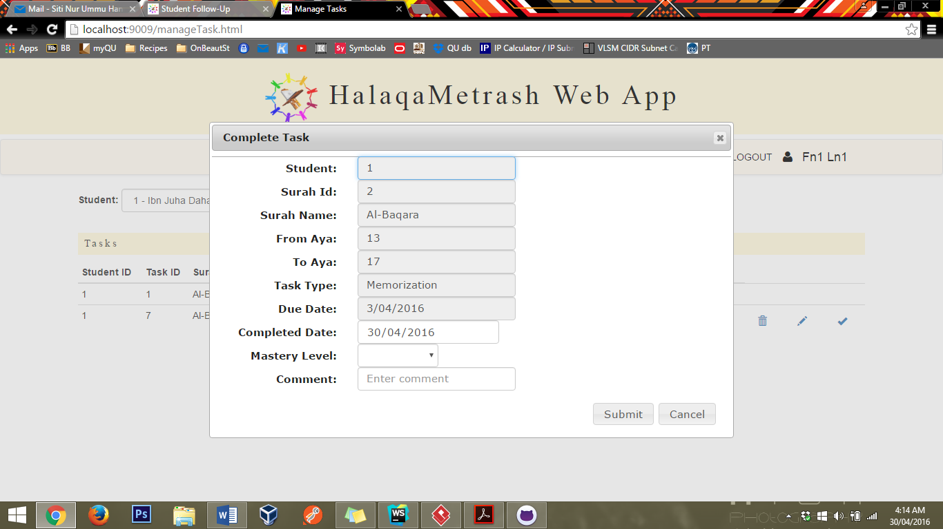

By default, completed date will set to today’s date

Only these 3 fields are editable for complete task

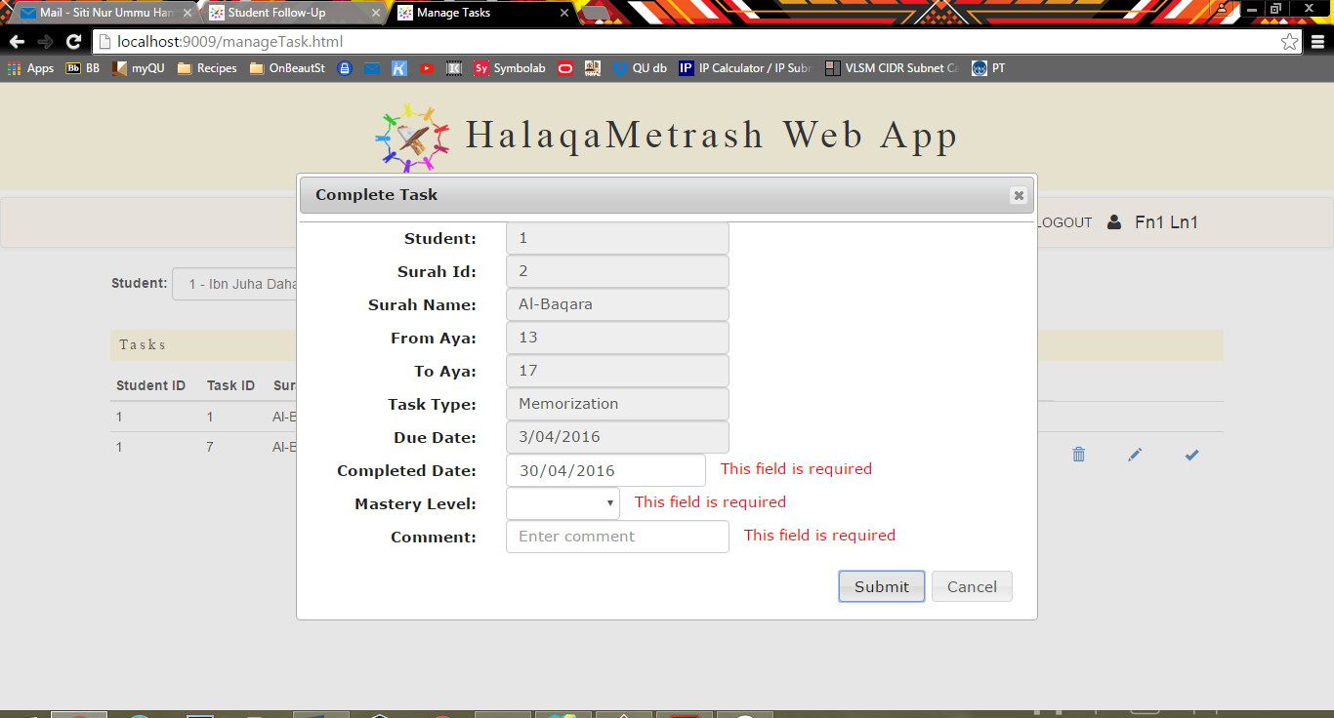

Missing field will result in this error.

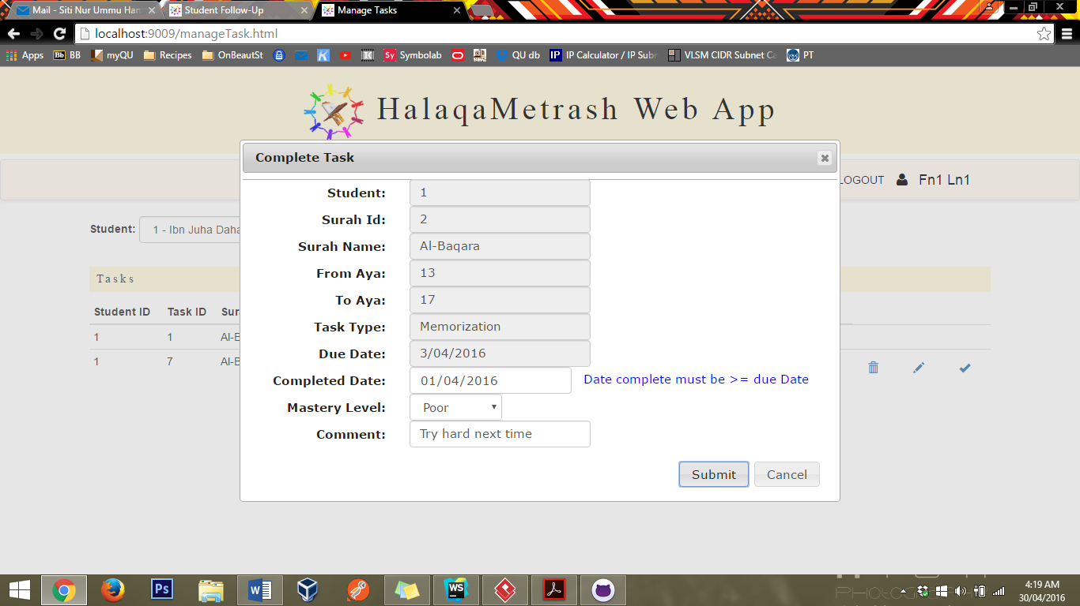

Completed date must be greater or equal to due date.

After successful complete task the table is updated

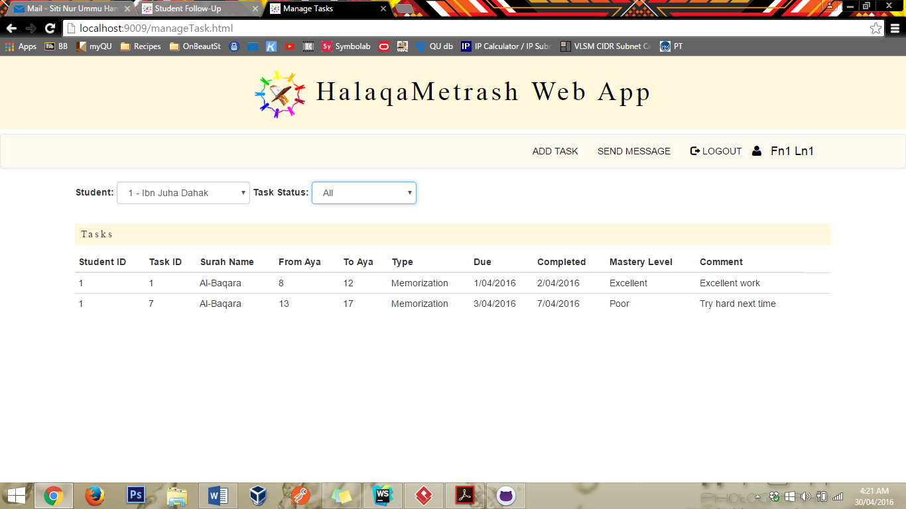

# Delete task

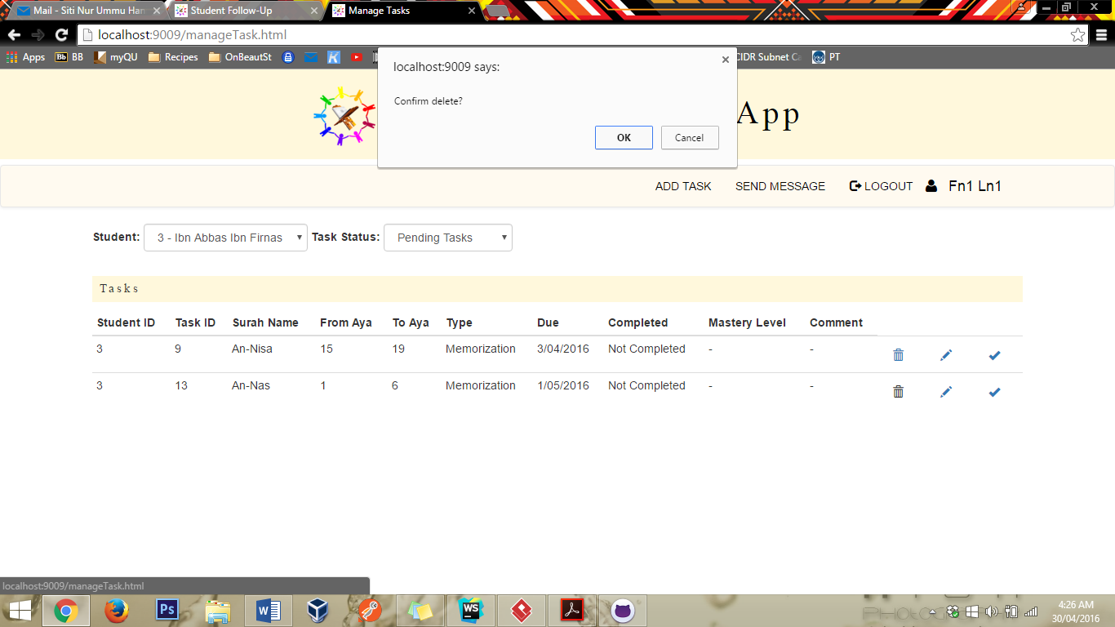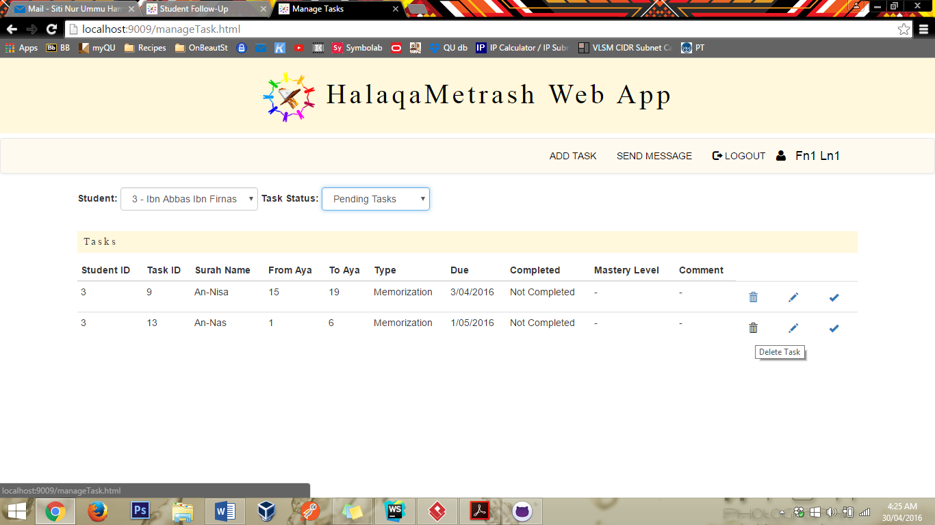

Choose a task, click on the thrash button.

Confirm dialog will pop up and click ok to delete

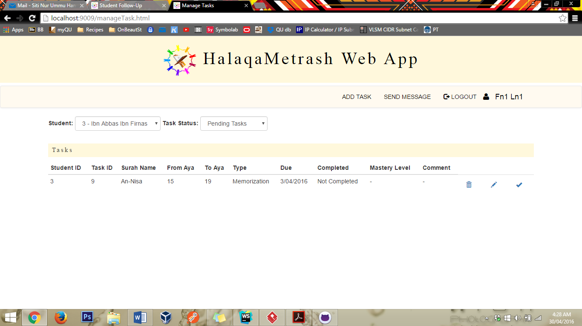

The deleted task automatically disappears.

# Add Task

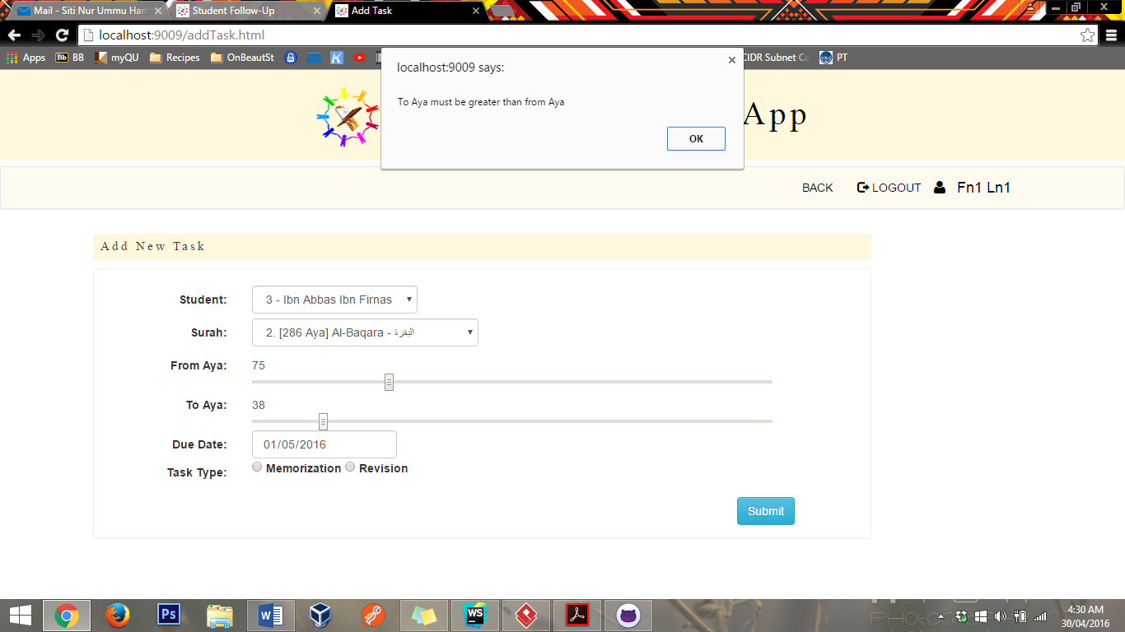

Fill the form.

This form will reject empty fields.

If toAya is less than fromAya it will will reject it and display warning

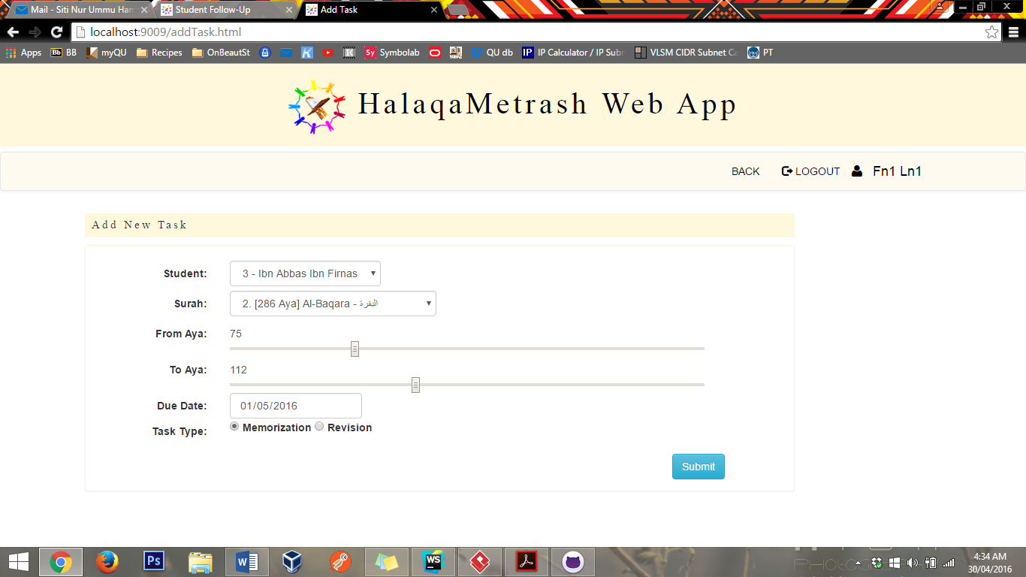

Go to manage task to see the newly added task:

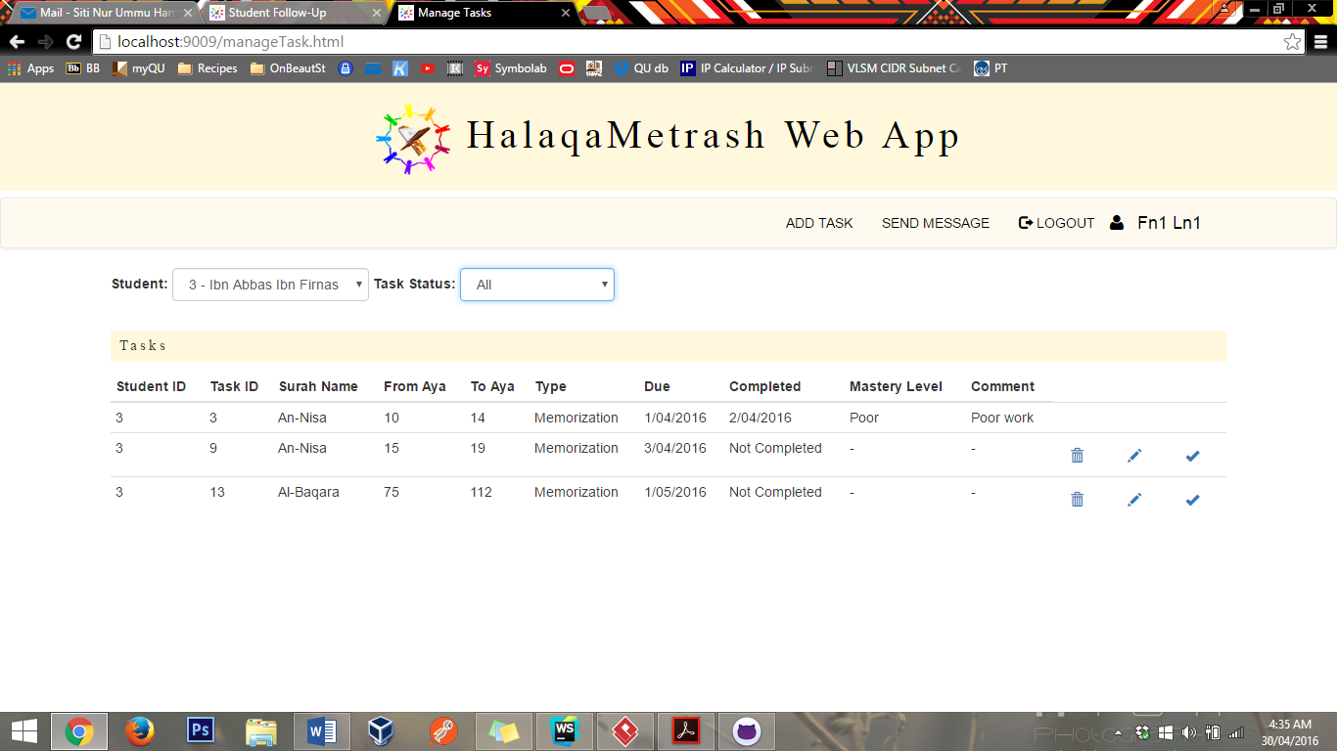

# Update task

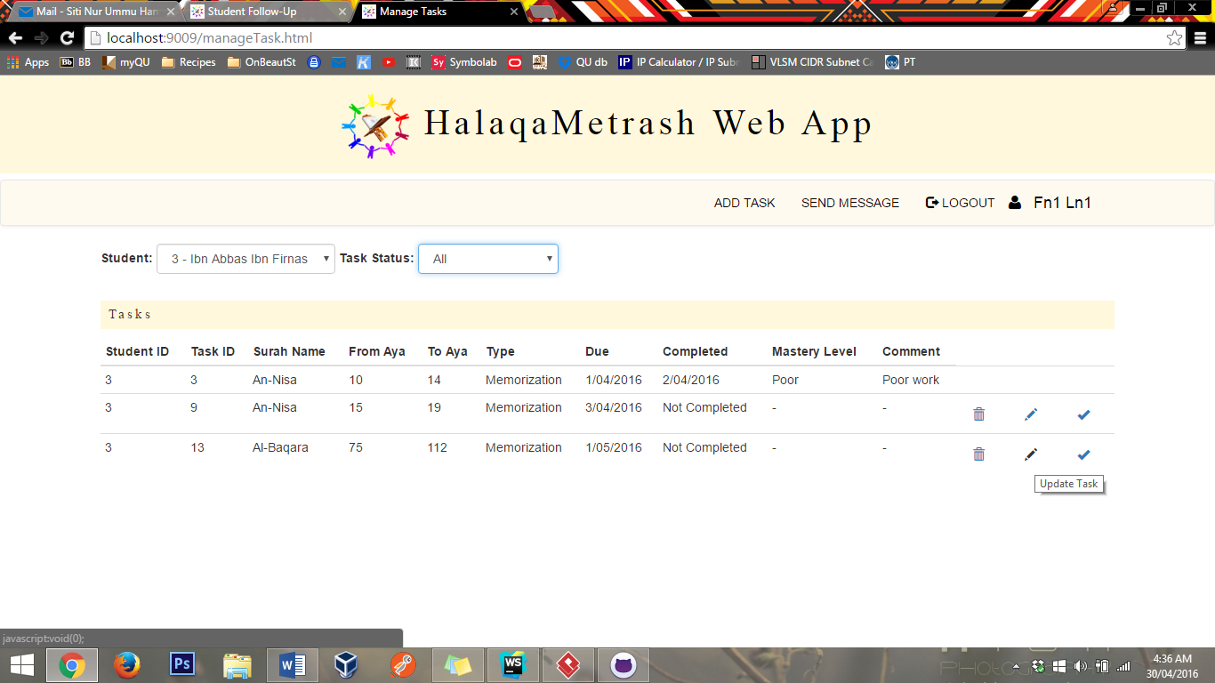

Choose a task, then click on the pencil button

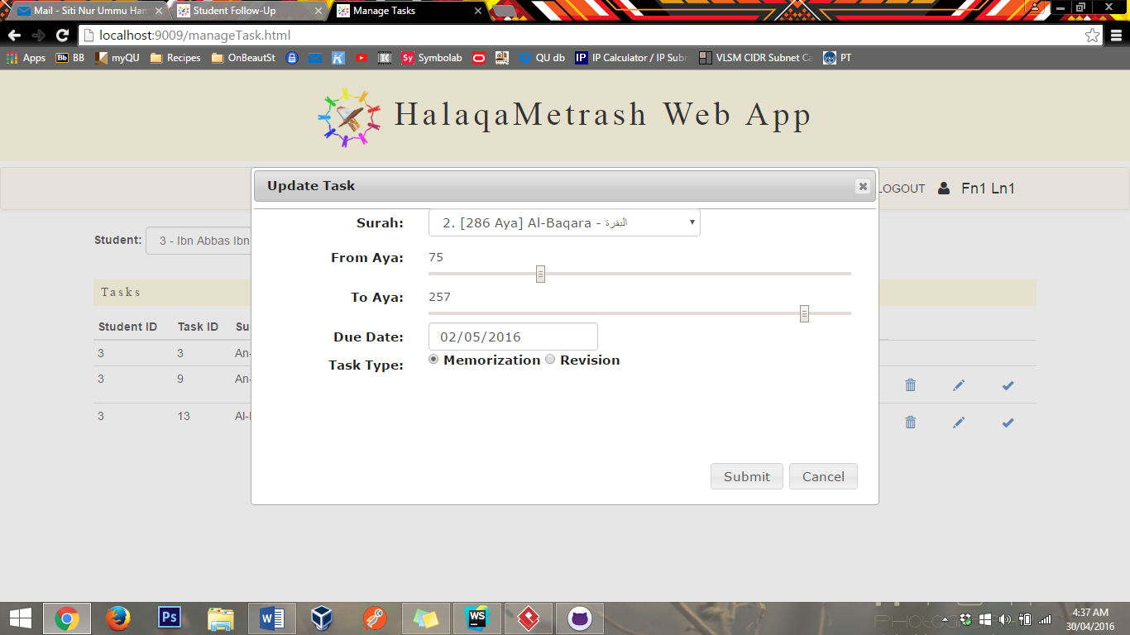

Current info will automatically appear on the input fields. Then, make the desired changes.

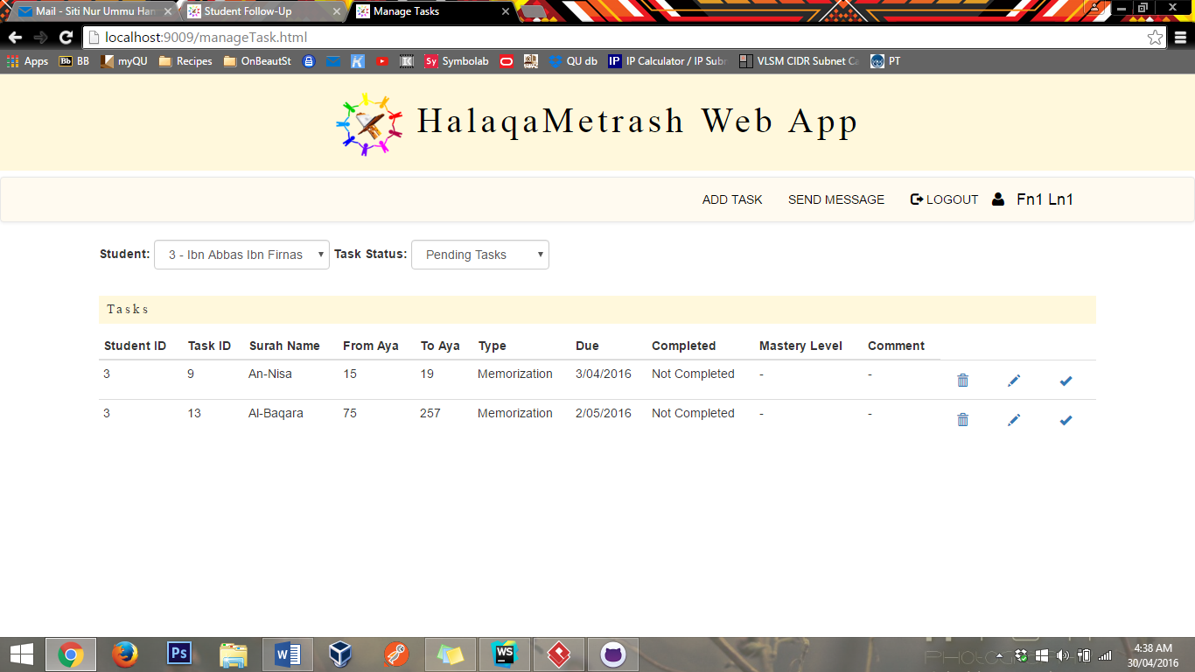

# Messaging

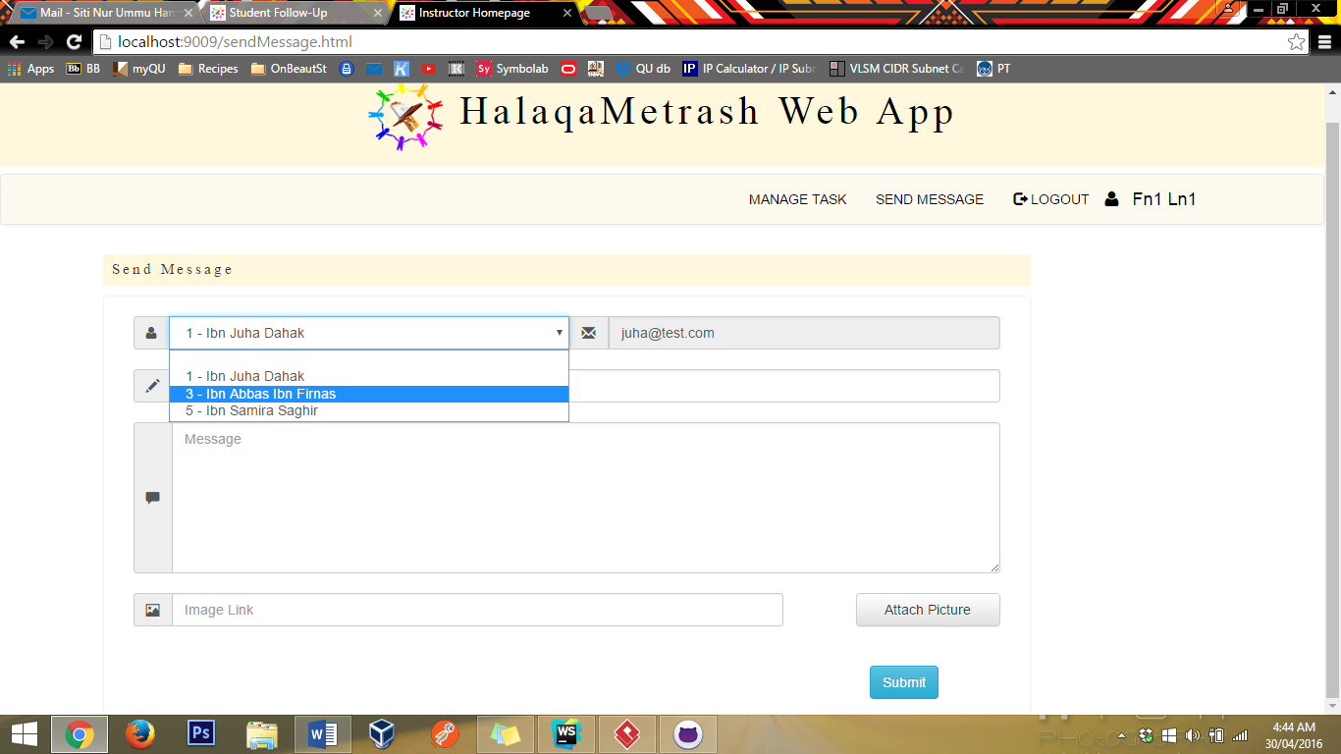

Choose one of his student.

The parent email will automatically filled

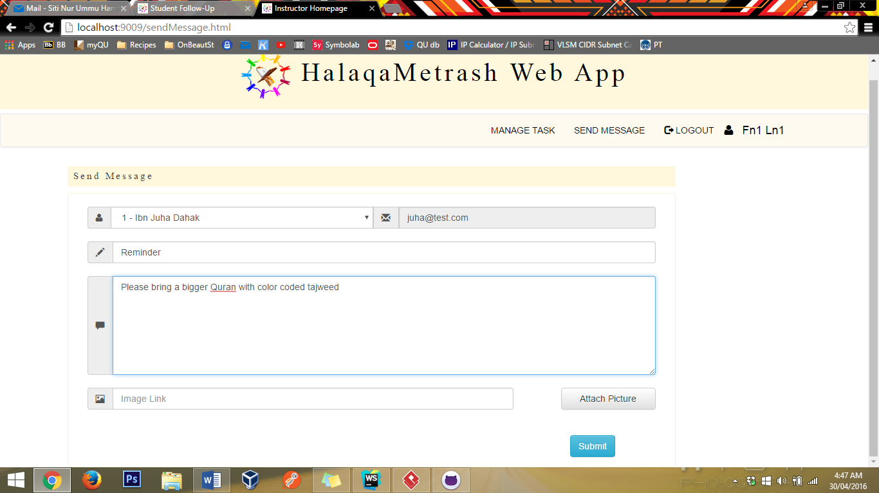

Picture uploading is not implemented

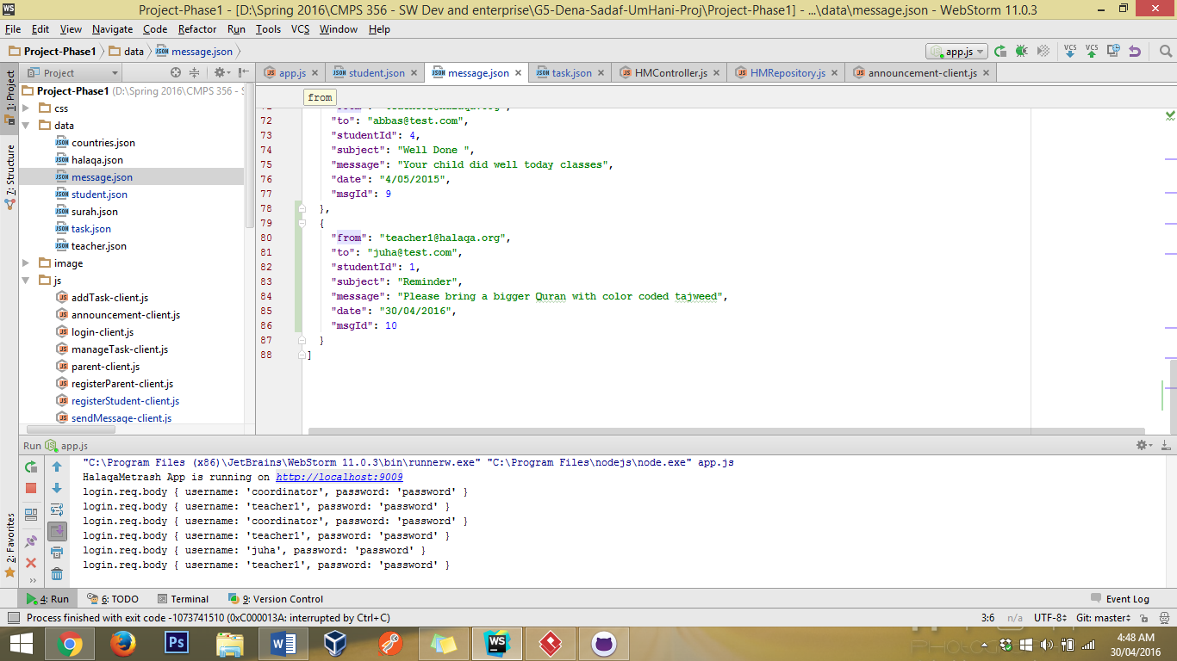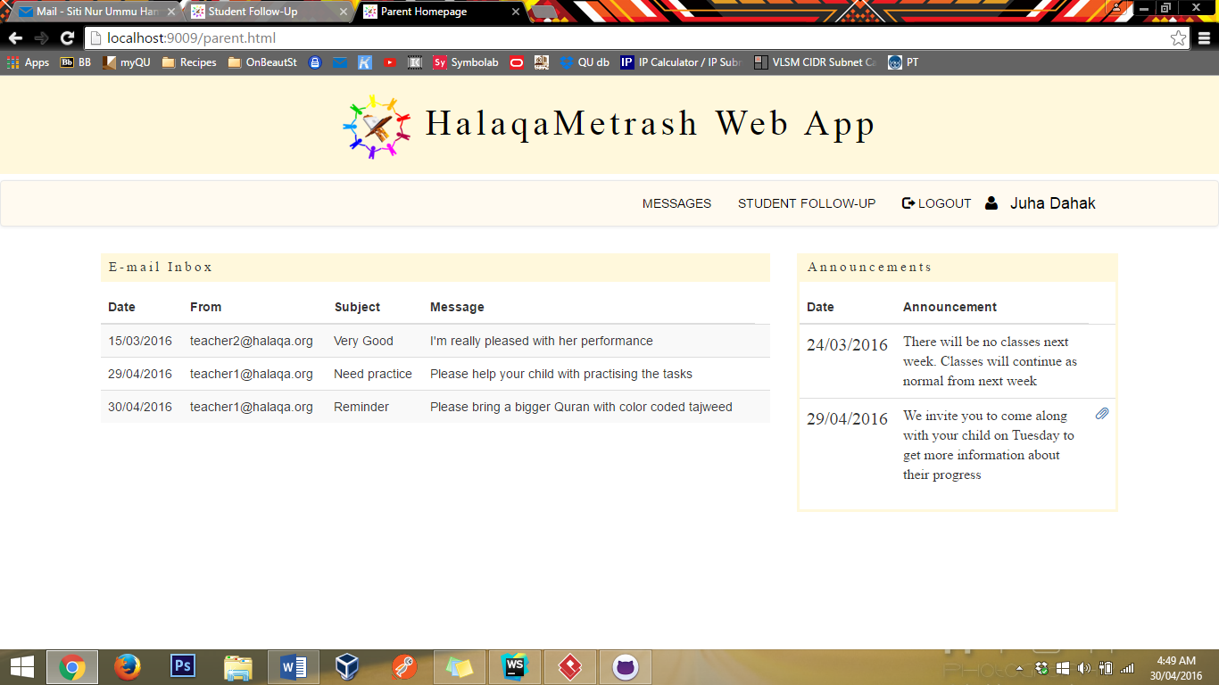

The email has been sent successfully and can be viewed in the parent’s page

# Announcements

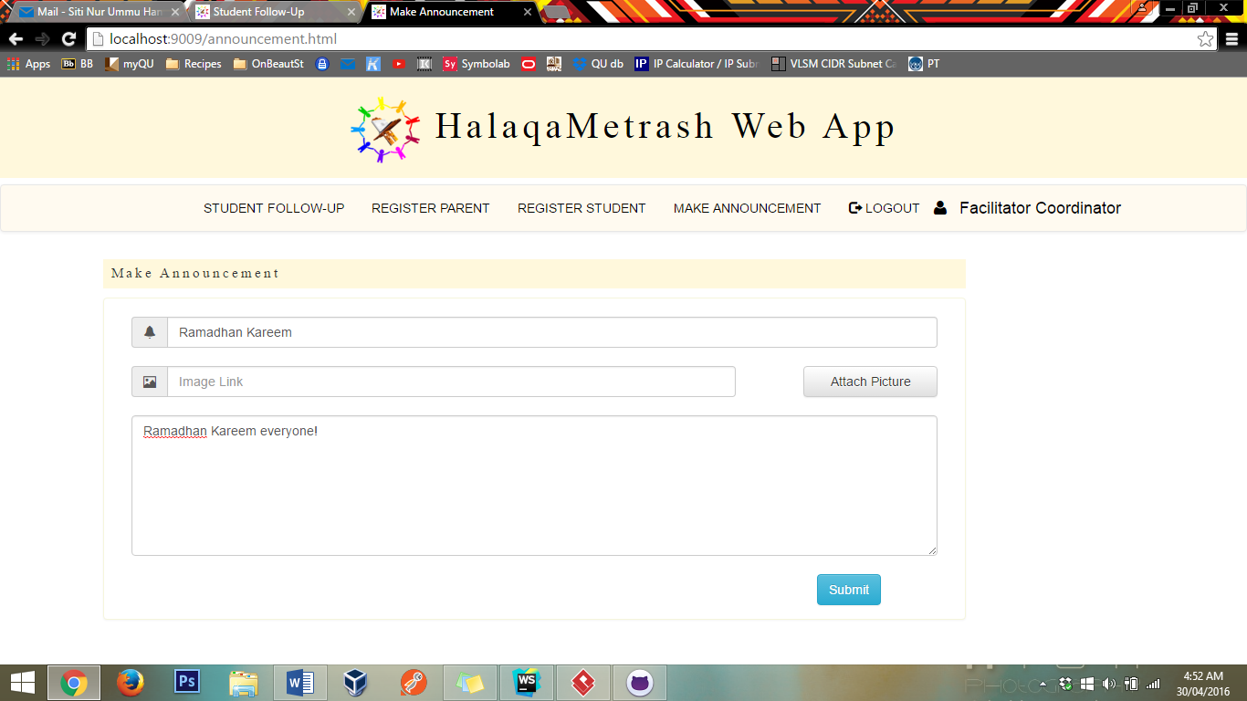

Picture uploading is not implemented

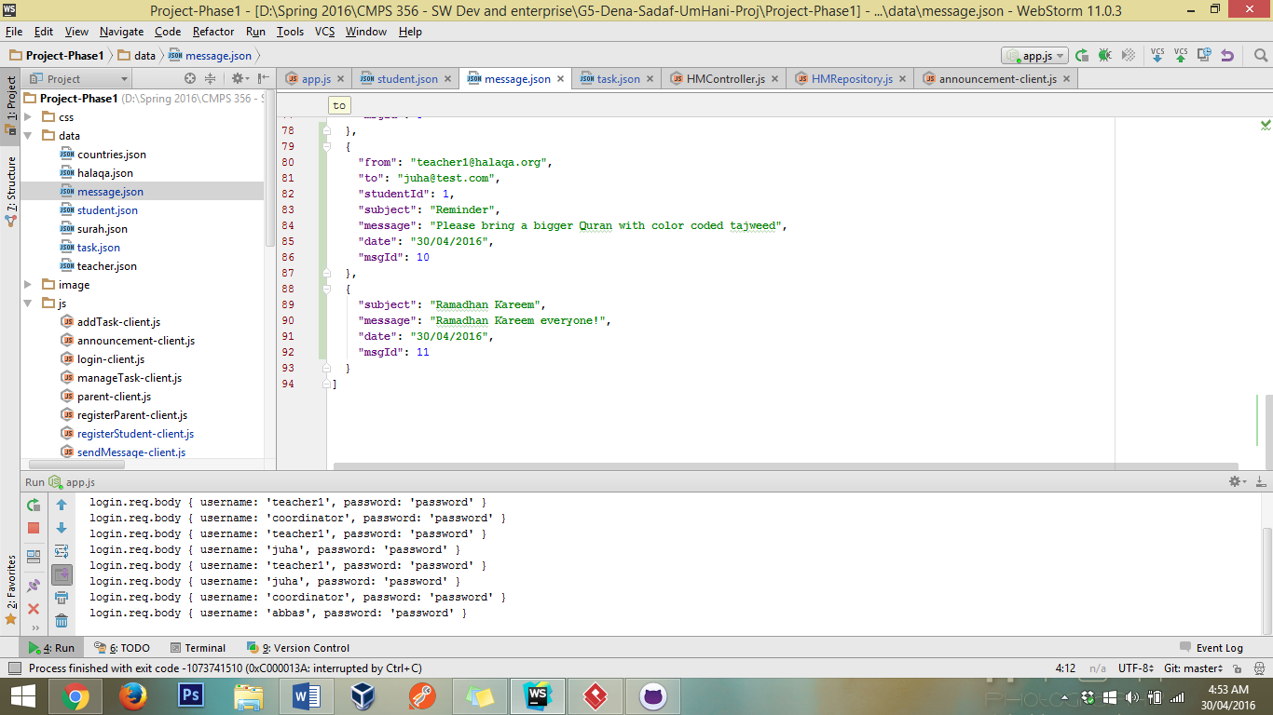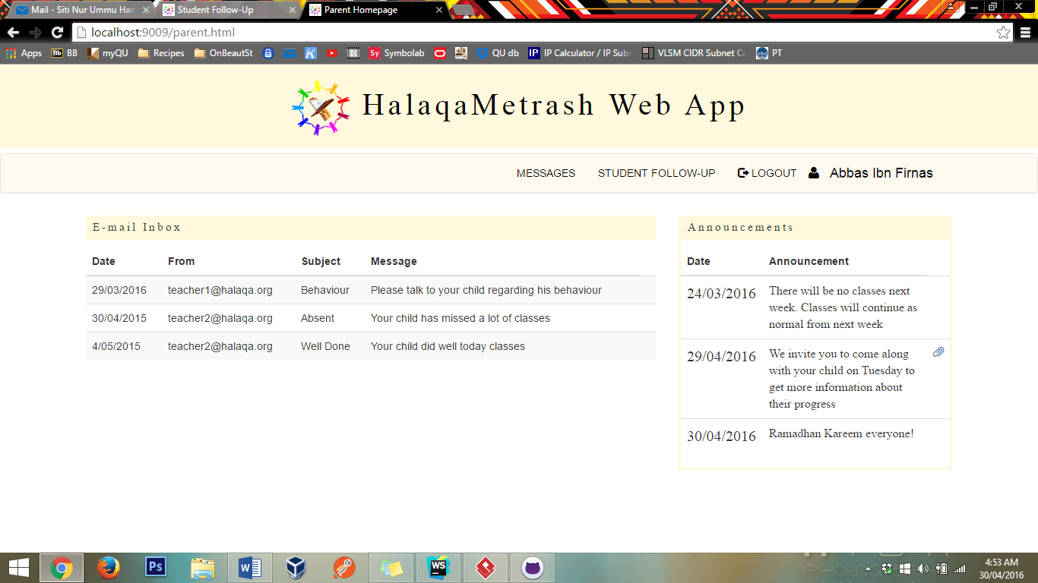

# Parent Student Follow-up

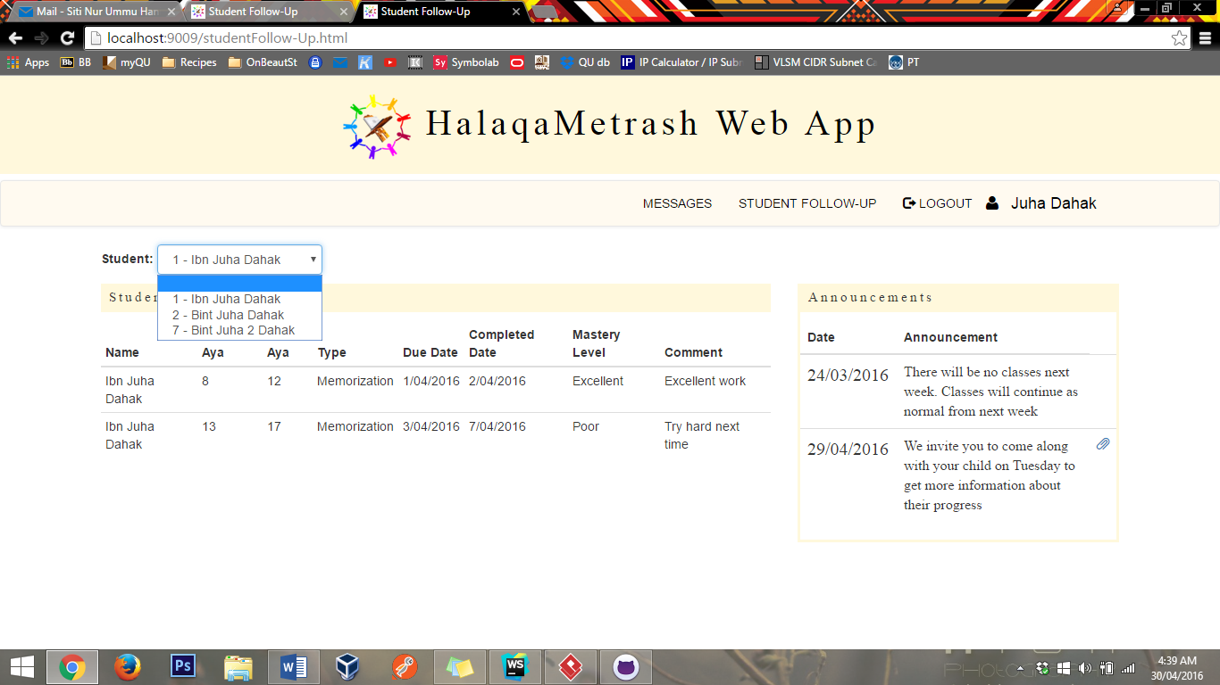

This parent can only see his children follow-up

Announcement on the right hand side

# Coordinator Student Follow-up

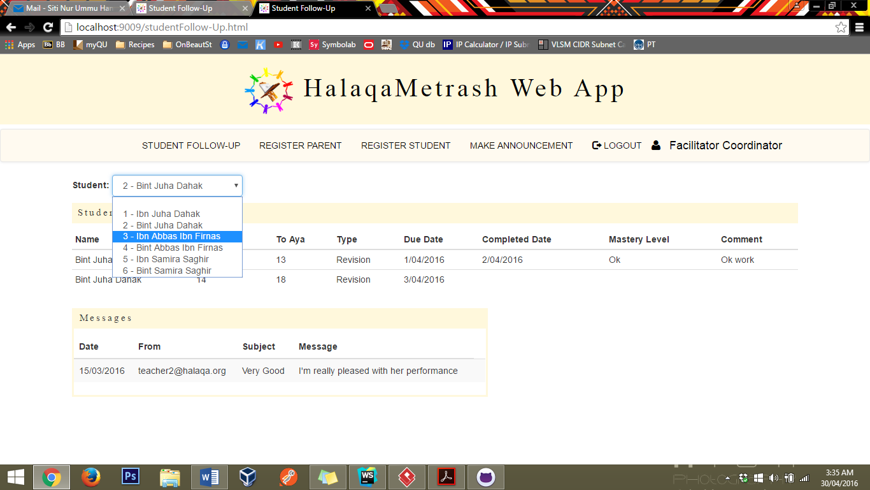

…as well as their message.

Coordinator can view any student progress…